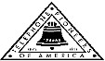 Jasper N. Keller Chapter #33
“Answering the call of those in need”
ISSUE 5, VOL. 8 August 2015

From the President’s desk…
Yikes, here it is August, two maybe three more months of good weather...then its break out the jackets, boots and snow shovels. But like Scarlet, I can't think about that right now.
Once, again the Pioneer Clown troupe will be participating in the Londonderry Old Home Day Parade. Come and join us, it is really a fun time. I wonder which politicians will be joining us this year. There is a large range to choose from. The Concord U8 girl’s softball (which the Pioneers sponsored) will be there with us as well.
The newly relocated Pioneer office is shaping up very nicely. Many thanks to Jason and "company" for hanging over 70 pictures for us. Two more tables of antiques to find homes for and it will/should be done. I need to go and round up some more antiques that are in storage, since FairPoint is closing various locations.
I am mentoring a Girl Scout to get her Silver Award; she is starting to restore a cemetery in Epsom. It dates back to the 1800’s. There is a lot of work to be done but she will get it done.
It has really been a rough few weeks for Richard and me…we have lost several close friends. These instances brings us back to what life is really like and puts it in a more positive prospective. My theory on life is; live life for today because tomorrow may not come and yesterday is gone.
Everyone have a great rest of the summer!

This really really made me chuckle!!!!



NH State U8 Girls Softball Champions
They did it!!! Pioneers softball team is the new reigning champions of U8 girls. It was a long time coming, but well worth every exciting minute. Three days of intense games, the weather was hot and humid, but the fans were tremendous. Many thanks to the coaches, score keepers, parents and local fans for their support and believing in these girls. Come and cheer for them in the August 15th Londonderry Old Home Days parade.



Monthly Meeting Dates and Times for the Chapter, Council & Life Member Clubs Cont.

Southern NH LMC: Will have the following: Luncheons schedule for 2015 are as follows 9/17 & 12/10 Please note your calendars.... They will be held at the The Yard Restaurant in Manchester, NH. If you are not on the Luncheon list or know someone who should be please, contact Bill Macy at 603 890 1572.

Northern NH LMC: Dates for 2015 luncheons are as follows: Thursday, August 6th at 11:30 am at Makris Lobster & Steakhouse, Rte 106, Concord, NH. Thursday, October 8th at 11:30 am at Town and Country Motor Inn, Shelburne, NH. Please contact Rachel French at rfrench89@gmail.com for more information.
Vermont
Vermont LMC: September 30th at 11:00 am in Montpelier at the Capital Plaza on 100 State St. We will be in the Ethan Allen Room. VT Chicken (with ham & cheese), potato, vegetable and raspberry-lemon cake for dessert. The cost is $15.00; checks need to reach Kay by September 1st. Please contact Kay Hopkins for more information about 2015 up coming luncheons at 802-684-2124 (Res), 802-535-4702 (cell).

Please help us keep in touch

If you know of anyone who is have a milestone birthday please let the Pioneer office know (603 656 8066). If a Pioneer passes away please once again let the Pioneer office know.


Monthly Meeting Dates and Times for the Chapter, Council & Life Member Clubs

Maine
Portland Council: Meets the 2nd Tuesday of each month from 9 am to 11 am at 1 Davis Farm Rd., Portland, Me. For details email: mainepioneers@fairpoint.com.

Bangor Life Member Club:
For more information please contact Cindy Black at eastport4the4th@msn.com.

Kennebec Life Member Club: Meets the last Wednesday of the month at 11:00 am alternately in Waterville or Augusta. Please contact Kathy Camann at 207-872-2355 or dkcamann@myfairpoint.net for locations or more information.
Portland Life Member Club: Meets the 2nd Thursday of each month at 11:30 am at Thatcher’s Restaurant, Foden Rd. S Portland, Me…Any retirees in the Portland area please come and join us.
New Hampshire
New Hampshire Council: Meets the 3rd Thursday of each month from 2 p.m. to 5 p.m. at 875 Holt Ave., Manchester, NH contact Pascale Coates for more details at 603 479 4718

Dover/Portsmouth LMC: Meets the 2nd Tuesday of each month starting at 11:30 am at Rogers Pizza at 869 Central Ave, Dover, NH. The spring luncheon will be June 9th, and the fall luncheon will be October 13th; both are at 11:30 at Granite Steak and Grill. Contact Kim Paradis for more details at 603 664 7744.

It's trivia time!
1. Which animal is associated with summer?
a. Tiger
b. Pig
c. Goat
d. Ox
2. Which country singer was born on the 21st of August 1938?
a. Travis Tritt
b. Garth Brooks
c. Kenny Rogers
d. Conway Twitty
3. What or who was the month of August named after?
a. A British King
b. A roman Emperor
c. The First Pope
d. An Ancient Battle
4. What is the birth flower for August?
a. Marigold
b. Gladiola
c. Violet
d. Pansy
5. What is the gemstone for August?
a. Sapphire
b. Peridot
c. Opal
d. Garnet
6. What famous rock concert opened on August 15th, 1969?
a. Monterey
b.Woodstock
c. Newport
d. Altamont
7. Which famous director died at the age of 83 on the 10th of August, 1996?
a. Richard Lester
b. Penny Marshall
c. Rex Tucker
d. Don Taylor
8. Which Alamo hero was born on the 17th of August, 1786?
a. David Bowie
b. Davy Crockett
c. Sam Houston
d. William Travis
9. If you were born in August what Zodiac sign would be associated with your birth?
a. Aries
b. Leo
c. Pieces
d. Aquarius
10, Michael Jackson was born on which of these days in August?
a. 19
b. 29
c. 9
d. 3


You can never have too many friends. Please ‘like’ us to keep up with what’s going on in the Jasper N. Keller Chapter #33. Here is the link to use for Facebook

https://www.facebook.com/pages/Pioneers-FairPoint-Jasper-N-Keller-Chapter-33/177159619001637?ref=hl



Want to get involved?



250 Brackett St, Portland, Me
Schedule for 2014
Volunteers Welcome!
Please contact Renee Dugas at
207-797-1635
Ronald McDonald Guest Chef
- August 10, 2015 – 45 Forest Ave
- September 14, 2015 – Life Members
- October 12, 2015 – 5 Davis Farm Rd
- November 9, 2015 – 45 Forest Ave
- December 14, 2015 – Life Members

If you would like to donate food to be used at the evening meals please contact Renee Dugas at 207 317 6798 or Christina Shea at 207 233 9133.

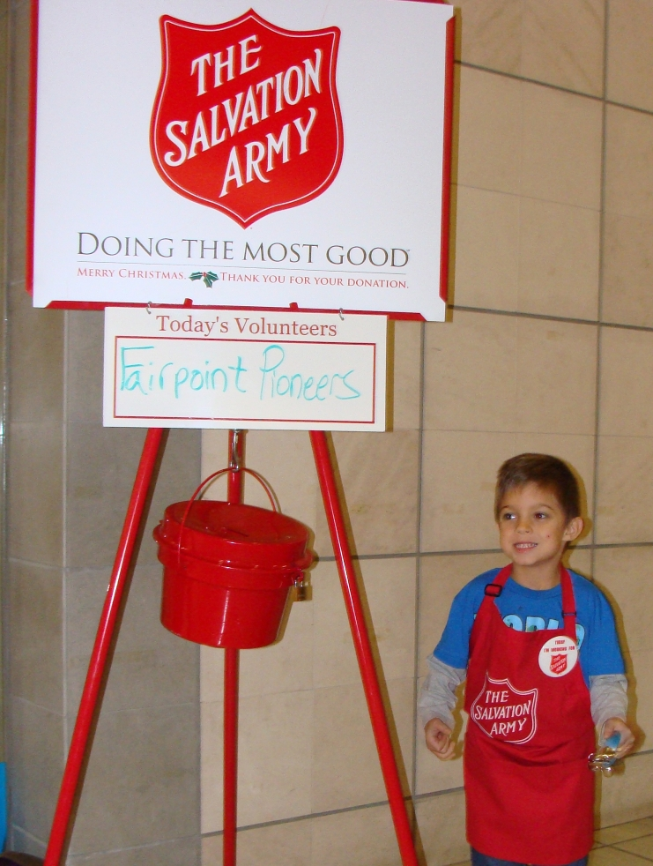
Food for thought
As seen by an "ex pat"

Who would have believed that the Confederate flag would come down, officially, in SC.? I thought it apropos to have two white, state troopers (the racial origins of the flag) lower, roll and then hand the artifact to a black trooper, representative liberator of the symbol of the former, slave-owning Confederacy.
Now the blacks are setting an example for the entire nation.
What next? Limited use of the American flag? Stay tuned.......
However, the other, historical news is the NYC ticker-tape parade, honoring the American women's soccer team. Yeah! Not only a "yeah" for women's and girls' sports but for soccer, in general.
A good day for many...sentimental for others...downright contrary for others...way it goes...change...

VT LMC 10 Week Club
The VT Life Member Club is running a 10 week club it will start July 29th and run through September 30th. Please send you tickets to Kay Hopkins, 45 Hill St., Apt 2, Danville, VT 05828. Please make the checks out to the VT LMC.
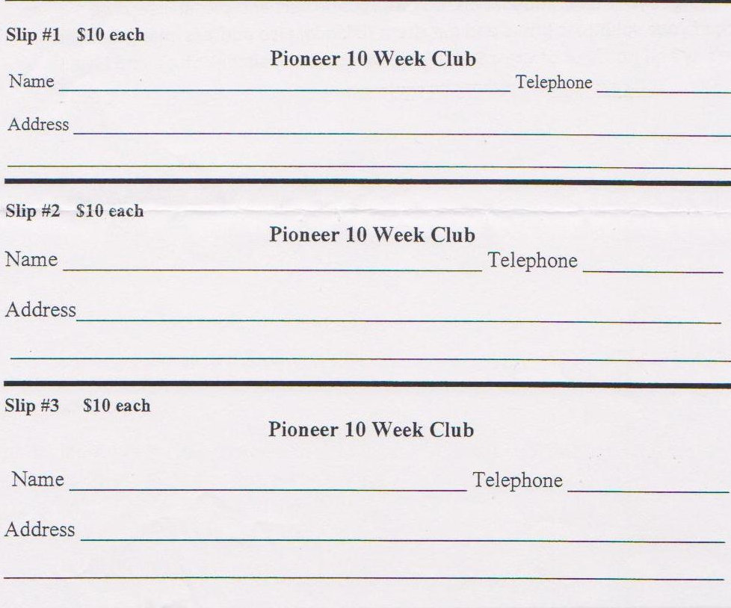

Trivia Answers - how well did you do?
1. Goat 2. Kenny Rogers 3. A Roman Emperor 4. Gladiola 5. Peridot
6. Woodstock 7. Rex Tucker 8. Davy Crocket 9. Leo 10. 29th
New Hampshire Council
In the spotlight!
Pascale Coates, President of the NH Council reports that the Council wanted to jump on board with the "Sock it to Me!" project and go one step further. Having volunteered many times at Beech St., school in Manchester, she understands how important it is for the intercity children to have a safe place to go in the summer. Fun in the Sun fit the bill, not only is there organized activities, but they are given breakfast and lunch. Summing is always a great thing. However, many of these children do not have bathing suits, towels, and flip fops to go into the pool with. The NH Council decided to donate gift cards so the councilors can purchase what is needed for the children to have a rewarding summer, and it truly will be Fun in the Sun.
I love my new sneakers!

I love my new bathing suit!
Thank you FairPoint Pioneers! We are having a great summer because of you.

Trivia: 1C, 2C, 3B, 4B, 5B, 6B, 7C, 8B, 9B, 10B
Bill Clinton has been in 3 porno films from e waste down.
It takes 3,000 cows to supply the NFL with enough leather for a year's supply of footballs.
The three most valuable brand names on earth: Marlboro, Coca Cola, and Budweiser, in that order.
Average life span of a major league baseball: seven pitches.
A duck's quack doesn't echo and no one knows why.
Richard Millhouse Nixon was the first US president whose name contains all the letters from the word "criminal." The second? William Jefferson Clinton.
American car horns beep in the tone of F.
No piece of paper can be folded more than 7 times.
Donkeys kill more people annually than plane crashes.
1 in every 4 Americans has appeared on television.
You burn more calories sleeping than you do watching television.
Oak trees do not produce acorns until they are fifty years of age or older.
The first product to have a bar code was Wrigley's gum.
The king of hearts is the only king without a mustache.
A Boeing 747s wingspan is longer than the Wright brother's first flight.
Venus is the only planet that rotates clockwise.
The first CD pressed in the US was Bruce Springsteen's "Born in the USA"
Apples, not caffeine, are more efficient at waking you up in the morning.
The 57 on the Heinz ketchup bottle represents the number of varieties of pickles the company once had.
The plastic things on the end of shoelaces are called "aglets."
Most dust particles in your house are made from dead skin.
The first owner of the Marlboro company died of lung cancer.
Barbie's full name is Barbara Millicent Roberts.
Betsy Ross is the only real person to ever have been the head on a Pez dispenser.
Marilyn Monroe had six toes.
Walt Disney was afraid of mice.
The sound of E.T. walking was made by someone squishing her hands in jelly.
Debra Winger (went to school with her) was the voice of E.T.
Pearls melt in vinegar.
Bill Clinton has been in 3 porno films from the waste down.
It takes 3,000 cows to supply the NFL with enough leather for a year's supply of footballs.
The three most valuable brand names on earth: Marlboro, Coca Cola, and Budweiser, in that order.
Average life span of a major league baseball: seven pitches.
A duck's quack doesn't echo and no one knows why.
Richard Millhouse Nixon was the first US president whose name contains all the letters from the word "criminal." The second? William Jefferson Clinton.

American car horns beep in the tone of F.
No piece of paper can be folded more than 7 times.
Donkeys kill more people annually than plane crashes.
1 in every 4 Americans has appeared on television.
You burn more calories sleeping than you do watching television.
Oak trees do not produce acorns until they are fifty years of age or older.
The first product to have a bar code was Wrigley's gum.
The king of hearts is the only king without a mustache.
A Boeing 747s wingspan is longer than the Wright brother's first flight.
Venus is the only planet that rotates clockwise.
The first CD pressed in the US was Bruce Springsteen's "Born in the USA"
Apples, not caffeine, are more efficient at waking you up in the morning.
The 57 on the Heinz ketchup bottle represents the number of varieties of pickles the company once had.
The plastic things on the end of shoelaces are called "aglets."
Most dust particles in your house are made from dead skin.
The first owner of the died of lung cancer.
Barbie's full name is Barbara Millicent Roberts.
Betsy Ross is the only real person to ever have been the head on a Pez dispenser.
Marilyn Monroe had six toes.
Walt Disney was afraid of mice.
The sound of E.T. walking was made by someone squishing her hands in jelly.
Debra Winger (went to school with her) was the voice of E.T.
Pearls melt in vinegar.
Bill Clinton has been in 3 porno films from the waste down.
It takes 3,000 cows to supply the NFL with enough leather for a year's supply of footballs.
The three most valuable brand names on earth: Marlboro, Coca Cola, and Budweiser, in that order.
Average life span of a major league baseball: seven pitches.
A duck's quack doesn't echo and no one knows why.
Richard Millhouse Nixon was the first US president whose name contains all the letters from the word "criminal." William Jefferson Clinton.

a

e

