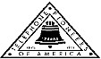 Jasper N. Keller Chapter #33
“Answering the call of those in need”
ISSUE 3, VOL. 8 August 2014

From the President’s desk…
As I stood looking out my kitchen window, waiting for the coffee to finish brewing, I happened to notice that there was a wasp nest being made on the front porch railing….curious things, wasps! There was one wasp, who, I supposed,was the nest inspector. They seemed to be going all over the outside of the nest…checking for whatever, they check for. The previous day’s work must have passed inspection, because all of a sudden there were 6 or 10 wasps getting to work building the nest. It was like the inspector had sounded the morning get to work bell. I was curious as to how they made that paper thin nest housing. So I checked the web, you can find anything on the web, and I mean anything. This is what I found: Wasps make their nests out of wood pulp, the same material used to make paper. The insects scrape wood from fences, trees, buildings, electric line poles and other sources. After collecting the material, the female worker chews the wood pulp to mix it with her saliva. Wasp saliva helps make the fibers soft, damp and malleable. After the chewing period, she adds the paste to the nest structure. Then she spreads and flattens it out with her mandibles and legs. When the pulp dries, it turns into a strong, hard paper, similar to card stock. How interesting, no wonder it feels like paper, not that I have felt many wasps nests. I will check on their progress though out the summer, but when the cold weather gets here and they are sleeping, I will relocate it, believe me!

How much do you know about the Statue of Liberty?
- The Statue of Liberty is located on Liberty Island, in what harbor?
- The Statue of Liberty commemorates the American Declaration of Independence and was a gift from whom?
- The statue was assembled on its pedestal after being constructed in France and sent to the US in what?
- It was dedicated on October 28, what year?
- The Statue of Liberty holds a torch and a tablet that has the date of what inscribed in it?
- A broken what lies at the feet of the statue?
- The Statue of Liberty stands how many feet tall from the ground to the torch?
- The head of the statue was displayed at what World's Fair in 1871?
- Liberty Island was previously called?
- There are replicas of the Statue of Liberty found in two cities, can you name them?

Monthly Meeting Dates and Times for the Chapter, Council & Life Member Clubs Cont.

Southern NH LMC: Will have the following: Luncheons schedule for 2014: Sept. 25th & December 11th (turkey dinner). They will be held at the The Yard Restaurant in Manchester, NH. If you are not on the Luncheon list or know someone who should be please contact Bill Macy at 603 890 1572.

Northern NH LMC: Dates for 2014 luncheons will be coming out soon. Please contact Rachel French at rfrench89@gmail.com for more information.

Vermont
Vermont LMC: Dates for the 2014 luncheons will be coming out soon. Please contact Kay Hopkins for more information at 802-684-2124 (house), 802-535-4702 (cell).

You can never have too many friends. Please ‘like’ us to keep up with what’s going on in the Jasper N. Keller Chapter #33. Here is the link to use for Facebook

https://www.facebook.com/pages/Pioneers-FairPoint-Jasper-N-Keller-Chapter-33/177159619001637?ref=hl

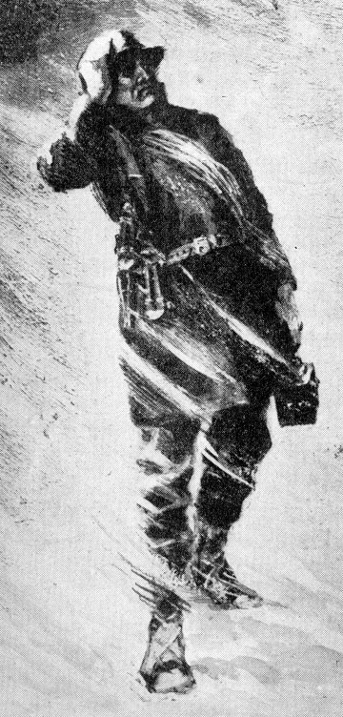

Monthly Meeting Dates and Times for the Chapter, Council & Life Member Clubs

Maine
Portland Council: Meets the 2nd Tuesday of each month from 9 am to 11 am at 1 Davis Farm Rd., Portland, Me. Contact Christina Shea for more details at: mainepioneers@fairpoint.com.

Bangor Life Member Club:
For more information please contact Cindy Black at eastport4the4th@msn.com.

Kennebec Life Member Club: Meets the last Wednesday of the month at 11:00 am alternately in Waterville or Augusta. Please contact Kathy Camann at 207-872-2355 or dkcamann@myfairpoint.net for locations or more information.
Portland Life Member Club: Meets the 2nd Thursday of each month at 11:30 am at Thatcher’s Restaurant, Foden Rd. S Portland, Me…Any retirees in the Portland area please come and join us.

New Hampshire

New Hampshire Council: Meets the 3rd Tuesday of each month from 3 p.m. to 6 p.m. at 875 Holt Ave., Manchester, NH contact Pascale Coates for more details at 603 479 4718

Dover/Portsmouth LMC: Meets the 2nd Tuesday of each month starting at 11:30 am at Rogers Pizza at 869 Central Ave, Dover, NH. Contact Kim Paradis for more details at 603 664 7744

The Best Way to Pray
A priest, a minister and a guru sat discussing the best positions for prayer, while a telephone repairman worked nearby. "Kneeling is definitely the best way to pray," the priest said.
"No," said the minister. "I get the best results standing with my hands outstretched to Heaven." "You're both wrong," the guru said. "The most effective prayer position is lying down on the floor." The repairman could contain himself no longer. "Hey, fellas," he interrupted, "The best prayin' I ever did was when I was hangin' upside down from a telephone pole."

Portland Maine Council Donates
Laptops!

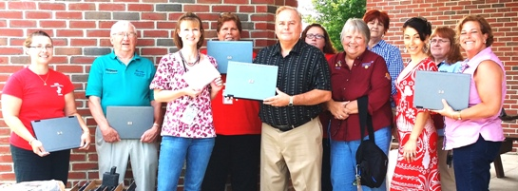
The Portland Maine Council was able to donate 11 used laptops and 1 brand new ipad to Grahamtastic Connections, a charity which provides laptops/tablets and internet connections for seriously ill children so that they may continue with their education while undergoing treatment for their condition. A spokesman for the organization related that "the kids absolutely light up when they get these devices" and that it provides a way to connect with family and friends as well as provide access to education. There are two categories of laptop requests: 1. Laptops which stay at a medical facility and rotate from patient to patient. 2. Laptops which may be borrowed by an individual patient during the course of treatment, typically 2 years. To learn more or to donate their website is www.grahamtastic.org.

Want to get involved?



Ronald McDonald House
250 Brackett St, Portland, Me
Schedule for 2013
Volunteers Welcome!
Please contact Christina Shea at
603 227 3557

2014 Dates & who’s Responsible
- August 11, 2014 – Life Members
- September 8, 2014 – 45 Forest Ave
- October 13, 2014 – 5 Davis Farm Rd
- November 10, 2014 – 45 Forest Ave
- December 8, 2014 – Life Members

What’s going on in the Council’s?

Maine – Portland Council

New Hampshire – NH Council

We need a secretary!
How about you? The NH Council is in need of a secretary and has some other opening on our council. If you’d like to join and help out, please contact Pascale Coates at Pascale.Coates@fairpoint.com.
Statue of Liberty
1. New York
2. France
3. 200 wooden crates
4. 1886
5. July IV MDCCLXXVI (July 4, 1776)
6. Shackles
7. 305 feet 6 inches
8. Paris
9. Bedloe’s
10. Paris & Las Vegas



New Keller Signature Project
Because of the wonderful relationship that the Pioneers have developed with the Sol mate company we are able to do this project at little to no cost.
“Sock – it – to me”
A new signature project from the Jasper N Keller Chapter #33



It consists of a pair of socks and a book, together in a zip lock baggie. These will be donated to homeless shelters and other organizations with in the Keller Chapter area. If you know of any agency that would benefit from this project please let the office know. If you would like to donate to this project please send all donations large or small to the Pioneer office 770 Elm St., Manchester, NH 03101.
For informational purposes only!
As you may or may not know the contracts between the IBEW local 2320, CWA local 1400 and FairPoint is set to expire at midnight on August 2. We as Pioneers have no comment on it, nor do we support either side. As a result, if there is a work stoppage the Pioneer office will be closed and I will be at home. If you need to reach me for any reason please feel free to call me at 603 623 4200 or my cell 603 860 3620.


The Statue of Liberty:
- New York harbor, USA.
- The people of France.
- Crates
- 1886
5. The American Declaration of Independence inscribed in it (July 4, 1776).
6. Chain
7. 305 feet
8. in Paris, 1878.
9. Bledloe's Island.
10. Paris, Las Vegas
Pioneer Death

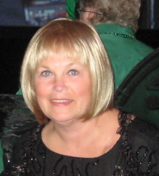
Punta Gorda, FL — Diane Nelson passed away suddenly on July 15, 2014. After high school she went to work as an operator for New England Telephone Company. Diane worked for many years as an Operator, Engineering Clerk and Secretary. After retiring, she was a Financial Administrator for the Telephone Pioneers of America. She was very active in Pioneering and a past Chapter President organizing and coordinating many conferences and conventions. Diane gave unselfishly of herself. She touched the heart and souls of so many people. She will be sadly missed. Condolences may be sent to: Fred Nelson, 2475 Dorsey Dr., Punta Gorda, FL 33983. A Celebration of Life for Diane Nelson will be held on Wednesday, August 20, 2014 from 6-8 PM at the Gloucester Elks, 97-101 Atlantic Rd, Gloucester MA. Directions: From Rte. 128: Follow Rte. 128N into Gloucester, Ma. through 2 rotaries, following signs towards Rockport. After exiting the second rotary, you will come to a set of lights. Go straight through the first set of lights to the second set of lights. Turn left onto Bass Ave. Stay on Bass Ave to the intersection of 127A to Rockport. Turn right onto Atlantic Rd. Stay on Atlantic Rd. You will soon see the Atlantic Ocean on your left. Continue bearing right until you see the Elks of Bass Rocks on your right. If you use map quest or a GPS, please make sure to to input 97 -101 ATLANTIC RD”. If you are instructed to take ANY exit off of Rt. 128, these directions are incorrect and you will surely get lost!

