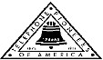 Jasper N. Keller Chapter #33
“Answering the call of those in need”
ISSUE 4, VOL. 2 February 2015

From the President’s desk…
Last week I was driving in Manchester and saw an older woman riding her electric scooter…as she turned the cornor the scooter died. Of course, you know me, I pull over to the side of the road and ask her if she needs any help….”Oh, can you help me” was her reply….seems that her battery had died…OK, I will push it for you…she gets back in and off we go…We got hooked up on the curb and a very nice homeless man offered to help. We tried to push it, but to no avail…she said the break wasn’t on…but on checking again, yup, you guessed it, the break was on…after that we were able to get her back on the sidewalk and off we went again…I can’t tell you how many people went by us and did nothing…what is wrong with this world, it didn’t take but a few minutes out of my day to help….She was happy, I was happy and the homeless man had a free lunch. It was a win win situation.
Well it is official I am now moved to the basement…what a mess, at least so I am told…It will take me a week of Sundays to find everything and get it back so I will know where it is….oh, well, always good to go through things and clean out. Please end this work stoppage soon.
Here it is Ground Hog Day….you know what means….time to take down you Christmas wreath….how will Punxsutawney Phil see his shadow in this snow?
Keller Chapter Fund Raiser

RADA Cutlery
On-line Ordering Instructions:
Go to this website: www.helpourfundraiser.com
Enter the following: Internet Ordering number: 504282/Password:
pioneer (small letters)
Click on BROWSE and browse the Catalog
Place your order.


Just to let everyone know, I have steak knives from RADA, and I absolutely love them. They are made here in the USA….I totally support made in America. A brief history of RADA: RADA Mfg. Co. is a manufacturer located in Waverly, Iowa and is the maker of RADA Cutlery. The company has been manufacturing 100% American-made cutlery since being founded in 1948. They are famous for their solid aluminum handles on their cutlery. RADA Cutlery was first produced shortly after World War II. Surplus military knife blades were available at a fraction of their value. The process for casting aluminum handles was developed. The availability of surplus blades was brief and was soon replaced by the high quality, surgical grade stainless steel blades still used today.

Monthly Meeting Dates and Times for the Chapter, Council & Life Member Clubs Cont.

Southern NH LMC: Will have the following: Luncheons schedule for 2015 are as follows 5/12, 9/17 & 12/10 Please note your calendars.... They will be held at the The Yard Restaurant in Manchester, NH. If you are not on the Luncheon list or know someone who should be please, contact Bill Macy at 603 890 1572.

Northern NH LMC: Dates for 2015 luncheons will be coming out soon. Please contact Rachel French at rfrench89@gmail.com for more information.

Vermont
Vermont LMC: Please contact Kay Hopkins for more information about 2015 up coming luncheons at 802-684-2124 (Res), 802-535-4702 (cell).

You can never have too many friends. Please ‘like’ us to keep up with what’s going on in the Jasper N. Keller Chapter #33. Here is the link to use for Facebook

https://www.facebook.com/pages/Pioneers-FairPoint-Jasper-N-Keller-Chapter-33/177159619001637?ref=hl

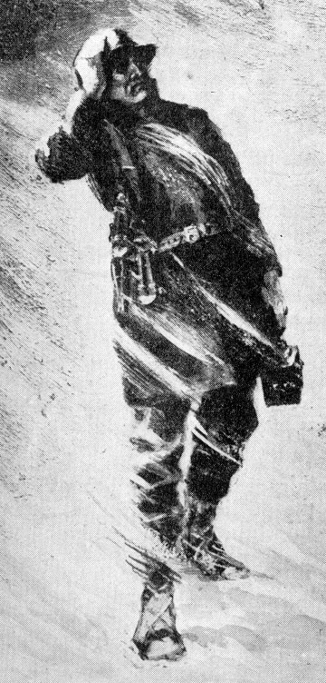

Monthly Meeting Dates and Times for the Chapter, Council & Life Member Clubs

Maine
Portland Council: Meets the 2nd Tuesday of each month from 9 am to 11 am at 1 Davis Farm Rd., Portland, Me. Contact Christina Shea for more details at: mainepioneers@fairpoint.com.

Bangor Life Member Club:
For more information please contact Cindy Black at eastport4the4th@msn.com.
Kennebec Life Member Club: Meets the last Wednesday of the month at 11:00 am alternately in Waterville or Augusta. Please contact Kathy Camann at 207-872-2355 or dkcamann@myfairpoint.net for locations or more information.
Portland Life Member Club: Meets the 2nd Thursday of each month at 11:30 am at Thatcher’s Restaurant, Foden Rd. S Portland, Me…Any retirees in the Portland area please come and join us.

New Hampshire
New Hampshire Council: Meets the 3rd Thursday of each month from 3 p.m. to 6 p.m. at 875 Holt Ave., Manchester, NH contact Pascale Coates for more details at 603 479 4718

Dover/Portsmouth LMC: Meets the 2nd Tuesday of each month starting at 11:30 am at Rogers Pizza at 869 Central Ave, Dover, NH. The spring luncheon will be June 9th, and the fall luncheon will be October 13th; both are at 11:30 at Granite Steak and Grill. Contact Kim Paradis for more details at 603 664 7744.

What’s going on in the Council’s?

There will be no new planned activities during the work stoppage, however, if any activities were planned prior to the work stoppage the activities will be done....

Bangor Council and Life Member Club

Bangor Council and Life Member Club would like to thanks to everyone that knitted or crocheted scarves, for the Maine Special Olympics Winter Games. We are up to 115 so far and counting!

A Maine Poem

It’s winter in Maine
And the gentle breezes blow
Seventy miles an hour.
At thirty-five below.

Oh, how I love Maine
When the snow’s up to your butt.
You take a breath of winter air
And you nose gets frozen shut.

Yes, the weather here is wonderful,
So I guess I’ll hang around.
I could never leave Maine
‘Cause I’m frozen to the ground!


Approximately 145 million valentines are sent in the U.S. each year according to estimates by the U.S. Greeting Card Association. That's second only to Christmas with 1.6 billion units, and is followed by Mother's Day with 133 million units.
Over 50 percent of all Valentine's Day cards are purchased in the six days prior to the holiday, making Valentine's Day a procrastinator's delight.

Want to get involved?





250 Brackett St, Portland, Me
Schedule for 2014
Volunteers Welcome!
Please contact Renee Dugas at
207-797-1635
Ronald McDonald Guest Chef
- February 9, 2015 – 45 Forest Ave
- March 9, 2015 – Life Members
- April 13, 2015 – 5 Davis Farm Rd
- May 11, 2015 – 45 Forest Ave
- June 8, 2015 – Life Members
- July 13, 2015 – 5 Davis Farm Rd
- August 10, 2015 – 45 Forest Ave
- September 14, 2015 – Life Members
- October 12, 2015 – 5 Davis Farm Rd
- November 9, 2015 – 45 Forest Ave
- December 14, 2015 – Life Members


If you would like to donate food to be used at the evening meals please contact Renee Dugas at 207 317 6798 or Christina Shea at 207 233 9133.

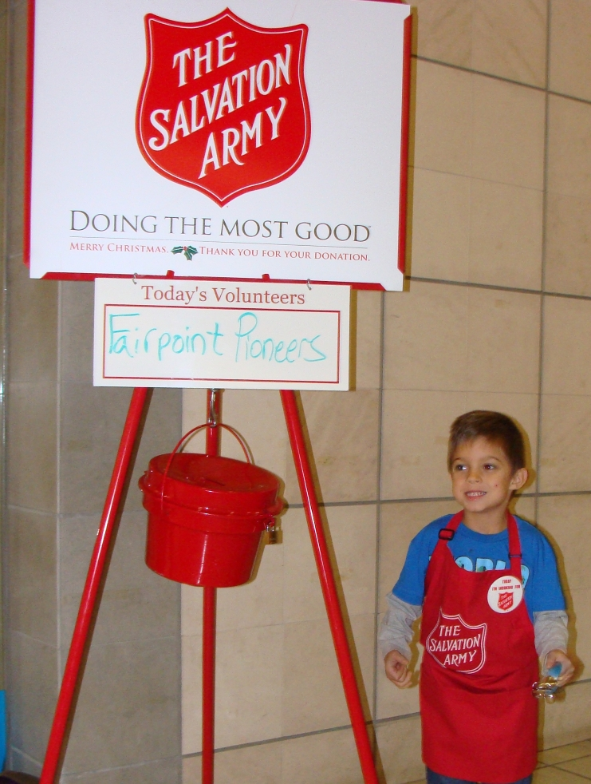
Maine

New Hampshire
2015 NH Special Olympics Winter Games
March 01, 2015 - March 03, 2015
Waterville Valley, NH
The Pioneers are looking for volunteers to help… Events include Alpine Skiing, Cross Country Skiing, Snowboarding, and Snowshoeing. Please contact Betty Hackett for rooms or to volunteer. Betty can be reached at ehackett@metrocast.net or home phone 603-267-8888 or cell phone 603-630-2619
Come and join us and see what all the fun is about!

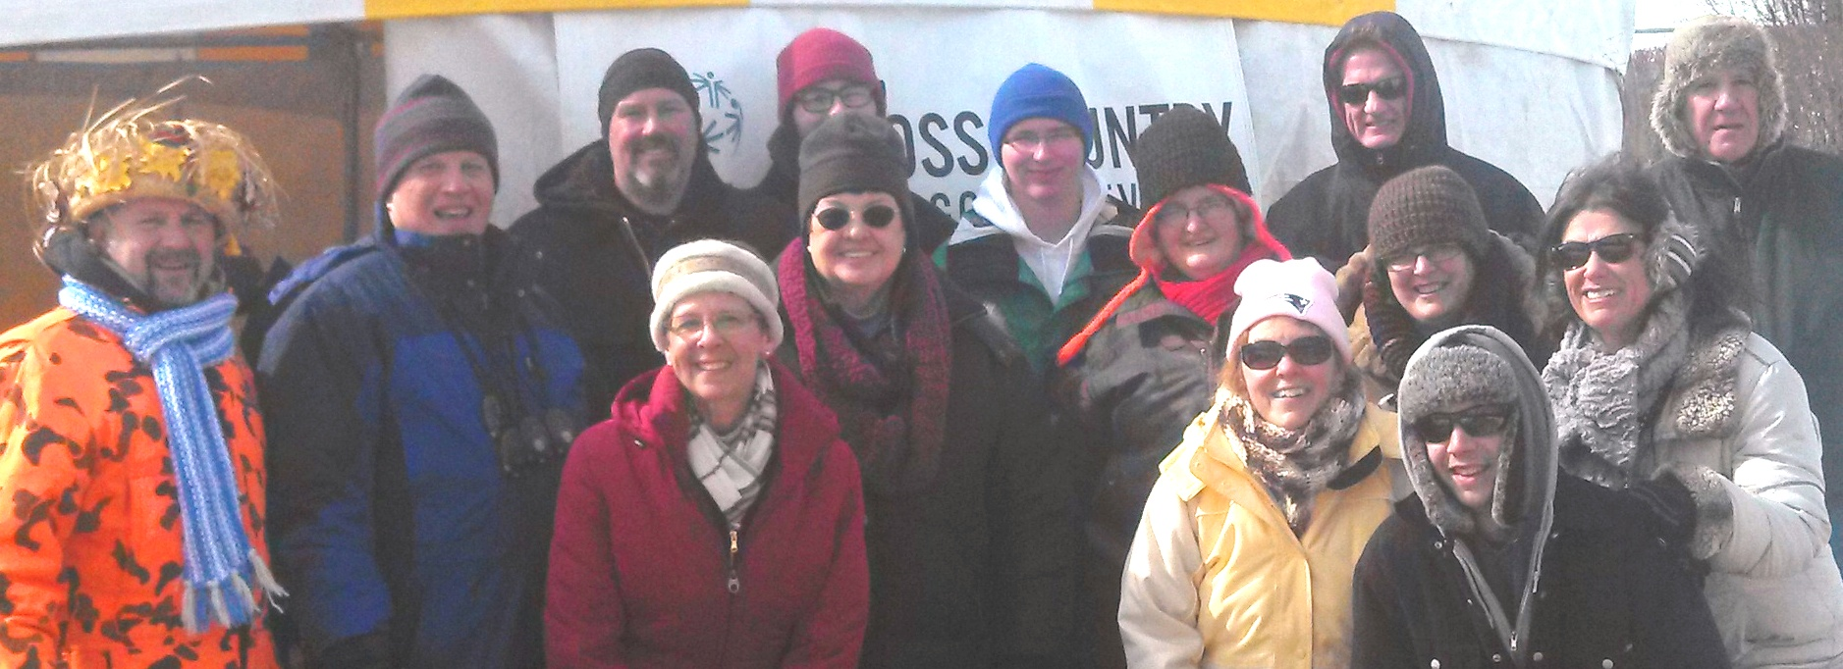
Waterville Valley Volunteers!
1934 Christmas catalogue from Montgomery Ward
What a deal….I love the cut-out! Perforated! Hand laced! Shoes


Portland Council

Portland Council President Christina Shea report the following ….Recently, I was helping a kindergartener get her shoes on after she took off her boots. I noticed that she had mismatched socks in the exact pattern that I know Portland Council had donated to a local outreach agency. I commented to the little girl about how cool I thought her socks are and I told her that I had a similar pair. Her eyes lit up and she told me how a nice lady who was helping her mommy gave them to her. She told me how warm they keep her feet and that she wished that she had more to keep her feet warm every day, all winter long!
I tearred up a bit knowing that the Pioneers helped her and how appreciative she was to have something so special. I am grateful that I was given this opportunity to see the fruits of our labor come full circle. It was really an inspiration moment to motivate me in our future projects.

As I was getting my morning cup of Dunkin’s one of the employees came running up to me to tell me that her daughter, who is in Kindergarten, came home with a pair of mismatched socks on since hers had gotten soaked out on the playground…and the plastic bag had the Pioneers name on it….Who nice, I had chatted with the teacher and told her about this program and she was very interested. I sent her a few samples of what we do…and she put them to good use! She also teaches summer school and will receive some of the new “Sock it to Me” bags. We will be adding sneakers to the bags this summer.

