 Jasper N. Keller Chapter #33
“Answering the call of those in need”
ISSUE 4, VOL. 1 January 2015

From the President’s desk…
Happy New Year to one and All….I hope that everyone had a great Christmas and New Year holiday.
Since it is a new year, I have started to make camping reservations for this season. Each winter I think we need to go to Florida or some place south that is warm….as I get older the cold weather is not fun! Speaking of getting older…the other day some one said to me….Well, you are in late 60’s aren’t you…wow, never really thought of myself as late for anything….well, almost anything….yikes.
The building here at 770 Elm St. is being remodeled and the Pioneer Office is moving to the basement. I will be down there all by myself…..a huge room. There will be an area for a conference table and great storage areas. Also, we will once again be able to display many of our antiques. If only I had known that when we had to remove the antiques; but, I can always get most of them back. Not sure who is going to pay to move them again…..
I will be attending a Leadership Conference in Orlando, FL, (hope it warm) also a National Board meeting. I fly out on 2/11 and return on 2/18. I had to change my return flight, I have no idea what I was thinking when I scheduled my flight…I was going through Detroit….right Detroit in the winter!!!! No so much. Be safe and warm!

10 Things You May Not Know About Snow

1. An average snowflake is made up of 180 billion molecules of water.
2. Around 12% of the Earth’s land surface is covered in permanent snow and ice.
3. Each year an average of 105 snow-producing storms affect the continental United States. A typical storm will have a snow-producing lifetime of two to five days and will bring snow to portions of several states.
4. All snowflakes have six sides.
5. Rochester, New York is the snowiest large city in the U.S., averaging 94 inches of snow a year.
6. Chionophobia is a fear of snow.
7. Snow is actually colorless. What little sunlight is absorbed by snow is absorbed uniformly over the wavelengths of visible light thus giving snow its white appearance.
8. People buy more cakes, cookies and candies than any other food when a blizzard is in the forecast.
9. A blizzard occurs when you can’t see for 1/4 mile. The winds are always 35 miles an hour or more. The storm must last at least 3 hours to be classed as a blizzard. If any of these conditions are less, it is only a snowstorm.
10. The average snowflake falls at a speed of 3.1 miles per hour.


Monthly Meeting Dates and Times for the Chapter, Council & Life Member Clubs Cont.

Southern NH LMC: Will have the following: Luncheons schedule for 2015 are as follows 5/12, 9/17 & 12/10 Please note your calendars.... They will be held at the The Yard Restaurant in Manchester, NH. If you are not on the Luncheon list or know someone who should be please, contact Bill Macy at 603 890 1572.

Northern NH LMC: Dates for 2015 luncheons will be coming out soon. Please contact Rachel French at rfrench89@gmail.com for more information.

Vermont
Vermont LMC: Please contact Kay Hopkins for more information about 2015 up coming luncheons at 802-684-2124 (Res), 802-535-4702 (cell).

You can never have too many friends. Please ‘like’ us to keep up with what’s going on in the Jasper N. Keller Chapter #33. Here is the link to use for Facebook

https://www.facebook.com/pages/Pioneers-FairPoint-Jasper-N-Keller-Chapter-33/177159619001637?ref=hl



Monthly Meeting Dates and Times for the Chapter, Council & Life Member Clubs

Maine
Portland Council: Meets the 2nd Tuesday of each month from 9 am to 11 am at 1 Davis Farm Rd., Portland, Me. Contact Christina Shea for more details at: mainepioneers@fairpoint.com.

Bangor Life Member Club:
For more information please contact Cindy Black at eastport4the4th@msn.com.

Kennebec Life Member Club: Meets the last Wednesday of the month at 11:00 am alternately in Waterville or Augusta. Please contact Kathy Camann at 207-872-2355 or dkcamann@myfairpoint.net for locations or more information.
Portland Life Member Club: Meets the 2nd Thursday of each month at 11:30 am at Thatcher’s Restaurant, Foden Rd. S Portland, Me…Any retirees in the Portland area please come and join us.

New Hampshire

New Hampshire Council: Meets the 3rd Thursday of each month from 3 p.m. to 6 p.m. at 875 Holt Ave., Manchester, NH contact Pascale Coates for more details at 603 479 4718

Dover/Portsmouth LMC: Meets the 2nd Tuesday of each month starting at 11:30 am at Rogers Pizza at 869 Central Ave, Dover, NH. Contact Kim Paradis for more details at 603 664 7744

What’s going on in the Council’s?

There will be no new planned activities during the work stoppage, however, if any activities were planned prior to the work stoppage the activities will be done....

New Hampshire Council
The New Hampshire Council Pioneer clown troupe missed both the Salem, NH and Manchester, NH Christmas parades this year. We are hoping to be in the St Patrick’s Day Parade.

Portland & NH Council’s
Once again this year we were awarded Dodd Fund Grant money. Again this year we will purchase hygiene kits for young adults (Grades 6th - 12th).

Each will contain:
1 Toiletry Case, Nylon, 9" × 6" × 4", Assorted Colors
1 Hairbrush, Plastic, Gray
1 Comb, 7", Black, Flexible
1 Tube Toothpaste, 4.75 oz. Mint Flavor
1 Toothbrush, Deluxe, Nylon, 52 Tufts
1 Toothbrush Holder, Plastic, Clear
1 Shampoo & Body Bath, 8 oz.
1 Bar Soap, 4.75 oz., Anti-Bacterial
1 Hand/Body Lotion, 4 oz. Bottle
1 Washcloth, 10" × 10" White, 100% Cotton
1 Deodorant, 1.5 oz. Roll-On
1 Dental Floss, Unwaxed, 12 Yards

Want to get involved?





250 Brackett St, Portland, Me
Schedule for 2014
Volunteers Welcome!
Please contact Renee Dugas at
207-797-1635
Ronald McDonald Guest Chef
For 2015
- January 12, 2015 – 5 Davis Farm Rd
- February 9, 2015 – 45 Forest Ave
- March 9, 2015 – Life Members
- April 13, 2015 – 5 Davis Farm Rd
- May 11, 2015 – 45 Forest Ave
- June 8, 2015 – Life Members
- July 13, 2015 – 5 Davis Farm Rd
- August 10, 2015 – 45 Forest Ave
- September 14, 2015 – Life Members
- October 12, 2015 – 5 Davis Farm Rd
- November 9, 2015 – 45 Forest Ave
- December 14, 2015 – Life Members

- Unfortunately, our guest chef for 1/12 was a little over anxious and arrived a week early…Oh, well, we can freeze and bring back at the correct date!


Maine
2015 Maine Special Olympic Winter Games
Jan 25 - 27, 2015
Carrabassett Valley, Me
The Pioneers are looking for volunteers to help with the Special Olympics at Sugarloaf from January 25 – 27, 2015. We need skiers and kitchen-server help. For more information, Please contact Karen Lessard, 136 Dennett Road, Biddeford ME 04005 or call 207-590-5440 (cell) or email kalanne@hotmail.com
New Hampshire
2015 NH Special Olympics Winter Games
March 01, 2015 - March 03, 2015
Waterville Valley, NH
The Pioneers are looking for volunteers to help… Events include Alpine Skiing, Cross Country Skiing, Snowboarding, and Snowshoeing. Please contact Betty Hackett for rooms or to volunteer. Betty can be reached at ehackett@metrocast.net or home phone 603-267-8888 or cell phone 603-630-2619

Come and join us and see what all the fun is about!
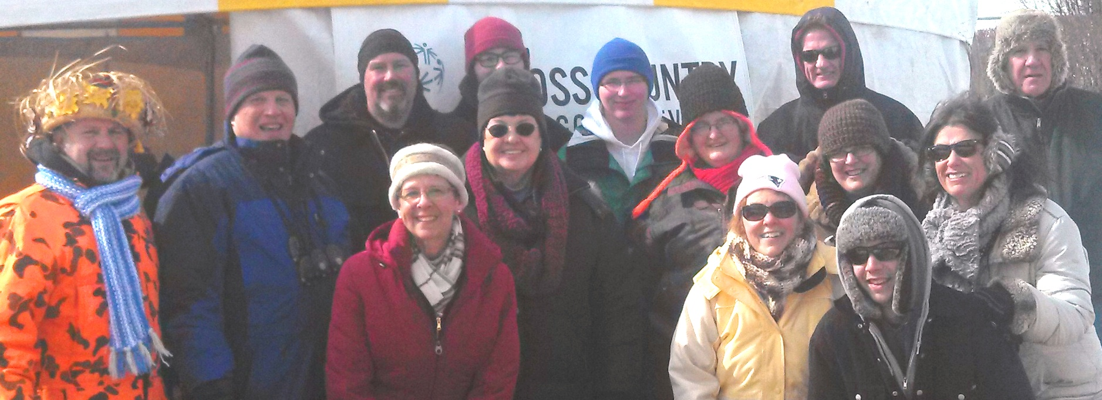
Waterville Valley Volunteers!

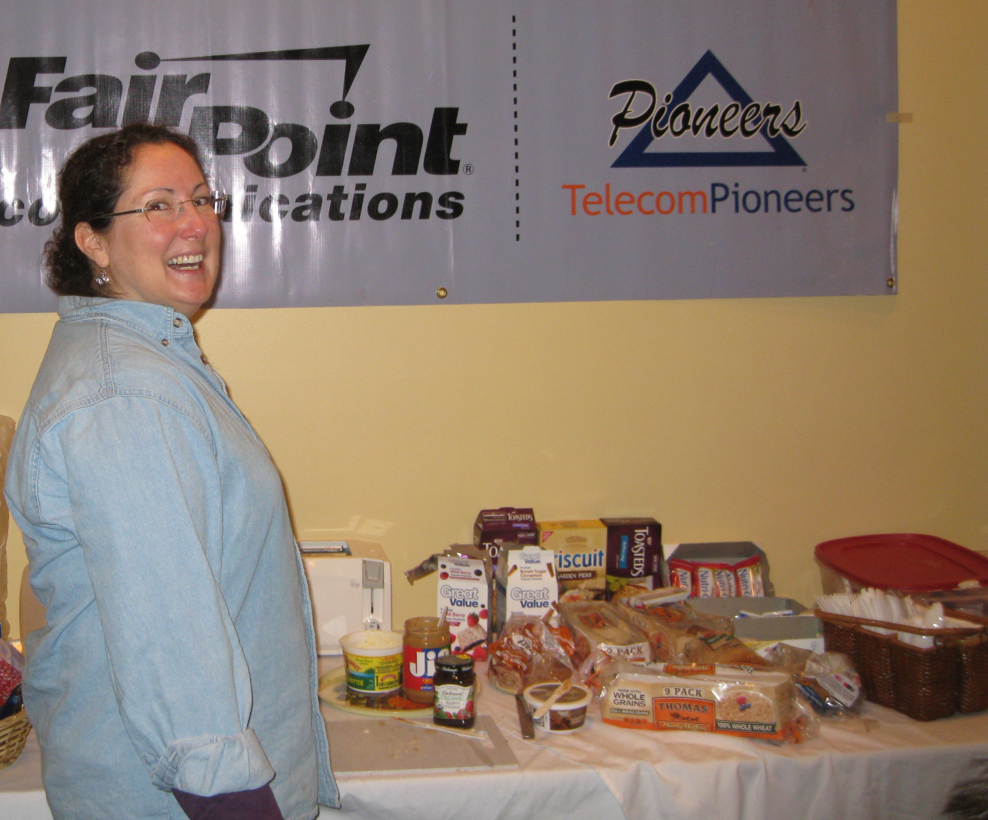
Karen Lessard at Sugarloaf, Me

VT LMC - 10 Week Winners
Congratulations to all the winners

Week 9
Mary Judd
Pat Marra
Alyssa Anderson
Wayne Prescott
Parker Mackey
Week 10
Tom Southworth
Carol Cross
Al Jarvis
Gary Simpson
Kitty Burke

Bonus Prize Winner of $10.00 – Frank Dattilio





