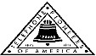 Jasper N. Keller Chapter #33
“Answering the call of those in need”
ISSUE 3, VOL. 7 July 2014

From the President’s desk…
I can’t believe the year is more than half over! Where does the time go? It seems as we were just putting up the Christmas tree and mailing out Christmas cards. Than you turn around and it’s 4th of July; Parades, fire works and family cook outs. I remember one 4th of July my sister, Susan and her husband Kurt were home from Germany. Kurt had never seen a 4th of July parade. So, I wanted to show him what it was like here in the USA on the 4th. Off to Cushing, Maine we went, to attend the Thomaston, Maine 4th of July parade. A good old fashion, down home parade. There were the usual participant’s fire trucks, a couple of floats, and the Lincolnville town band, on a flat bed, most were way too old to march. They could however, belt a good patriotic tune. Kids on bicycles, which they had been decorated with red, white and blue crepe paper, kids pulling little brothers or sisters in wagons all decorated as well, not to be out done by the “bike kids”..a couple of motorcycles…not sure if they were supposed to be there or just got caught trying to pass through town and of course, the local VFW with the flags and veterans in various modes of transportation. And for us the best part was my friend and his model T truck….some local kids were hanging all over it and throwing out candy. That’s what it’s all about….friends, family and a good hot dog after all is said and done. All Kurt could do was to shake his head and marvel at it all.

Historical Trivia
Candy bars are ever evolving, with new ones added and old ones phased out. This makes their history particularly interesting.
- In 1932, the original Three Musketeers bar has three pieces of candy; one chocolate, one vanilla and one strawberry.
- Frank and Ethel Mars introduced the Snickers bar in 1929. They named it after their family’s horse.
- There is controversy as to who the Baby Ruth bar is named after. The Curtiss Candy Company, who introduced it in 1921, claims it was named after Grover Cleveland’s daughter Ruth. Skeptics argue that it was actually named after baseball legend Babe Ruth, but an endorsement deal fell through.
- Ordinary citizen Nikola Jovanovich named the Butterfinger candy bar. He won a naming contest by sending in his own nickname, which he got for being a klutz.
- The town of Derry Church, Pennsylvania, was renamed Hershey to honor Milton Hershey and his candy bar factory.
- Philip Silvershein named a pyramid candy bar with chocolate, raisins, cashews and Brazil nuts after his granddaughter. The name he gave it: Chunky.

Calendar of upcoming Events – Mark your calendars
Portland Council

New Hampshire Council

Monthly Meeting Dates and Times for the Chapter, Council & Life Member Clubs Cont.

Southern NH LMC: Will have the following: Luncheons schedule for 2014: Sept. 25th & December 11th (turkey dinner). They will be held at the The Yard Restaurant in Manchester, NH. If you are not on the Luncheon list or know someone who should be please contact Bill Macy at 603 890 1572.

Northern NH LMC: Dates for 2014 luncheons will be coming out soon. Please contact Rachel French at rfrench89@gmail.com for more information.

Vermont
Vermont LMC: Dates for the 2014 luncheons will be coming out soon. Please contact Kay Hopkins for more information at 802-684-2124 (house), 802-535-4702 (cell).

You can never have too many friends. Please ‘like’ us to keep up with what’s going on in the Jasper N. Keller Chapter #33. Here is the link to use for Facebook

https://www.facebook.com/pages/Pioneers-FairPoint-Jasper-N-Keller-Chapter-33/177159619001637?ref=hl

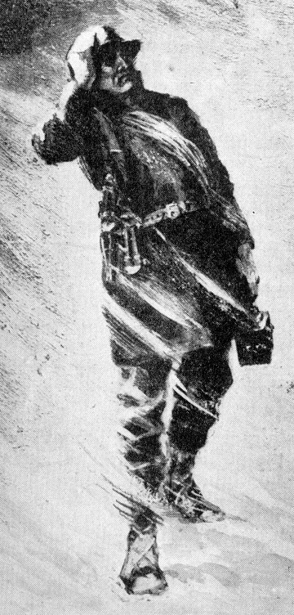

Monthly Meeting Dates and Times for the Chapter, Council & Life Member Clubs

Maine
Portland Council: Meets the 2nd Tuesday of each month from 9 am to 11 am at 1 Davis Farm Rd., Portland, Me. Contact Christina Shea for more details at: mainepioneers@fairpoint.com.

Bangor Life Member Club:
For more information please contact Cindy Black at eastport4the4th@msn.com.

Kennebec Life Member Club: Meets the last Wednesday of the month at 11:00 am alternately in Waterville or Augusta. Please contact Kathy Camann at 207-872-2355 or dkcamann@myfairpoint.net for locations or more information.
Portland Life Member Club: Meets the 2nd Thursday of each month at 11:30 am at Thatcher’s Restaurant, Foden Rd. S Portland, Me…Any retirees in the Portland area please come and join us.

New Hampshire

New Hampshire Council: Meets the 3rd Tuesday of each month from 3 p.m. to 6 p.m. at 875 Holt Ave., Manchester, NH contact Pascale Coates for more details at 603 479 4718

Dover/Portsmouth LMC: Meets the 2nd Tuesday of each month starting at 11:30 am at Rogers Pizza at 869 Central Ave, Dover, NH. Contact Kim Paradis for more details at 603 664 7744

Membership Drives

Membership drives were recently held at 5 Davis Farm Rd., Portland, ME. 875 Holt Ave., Manchester, NH and 100 Gay St., Manchester, NH…and 57 St Thomas St. Dover, NH. When FairPoint purchased “us” from Verizon they weren’t able to transfer the dues over. Therefore, we have worked very hard to resign people. Many still think their dues are still coming out of their pay check. Not, so….we have been very successful with this project. As an incentive to rejoin we held a drawing at each location for a gas card. Donna Stevens was the lucky winner at 5 Davis Farm Rd., Portland, ME.
And the winner is!!!!

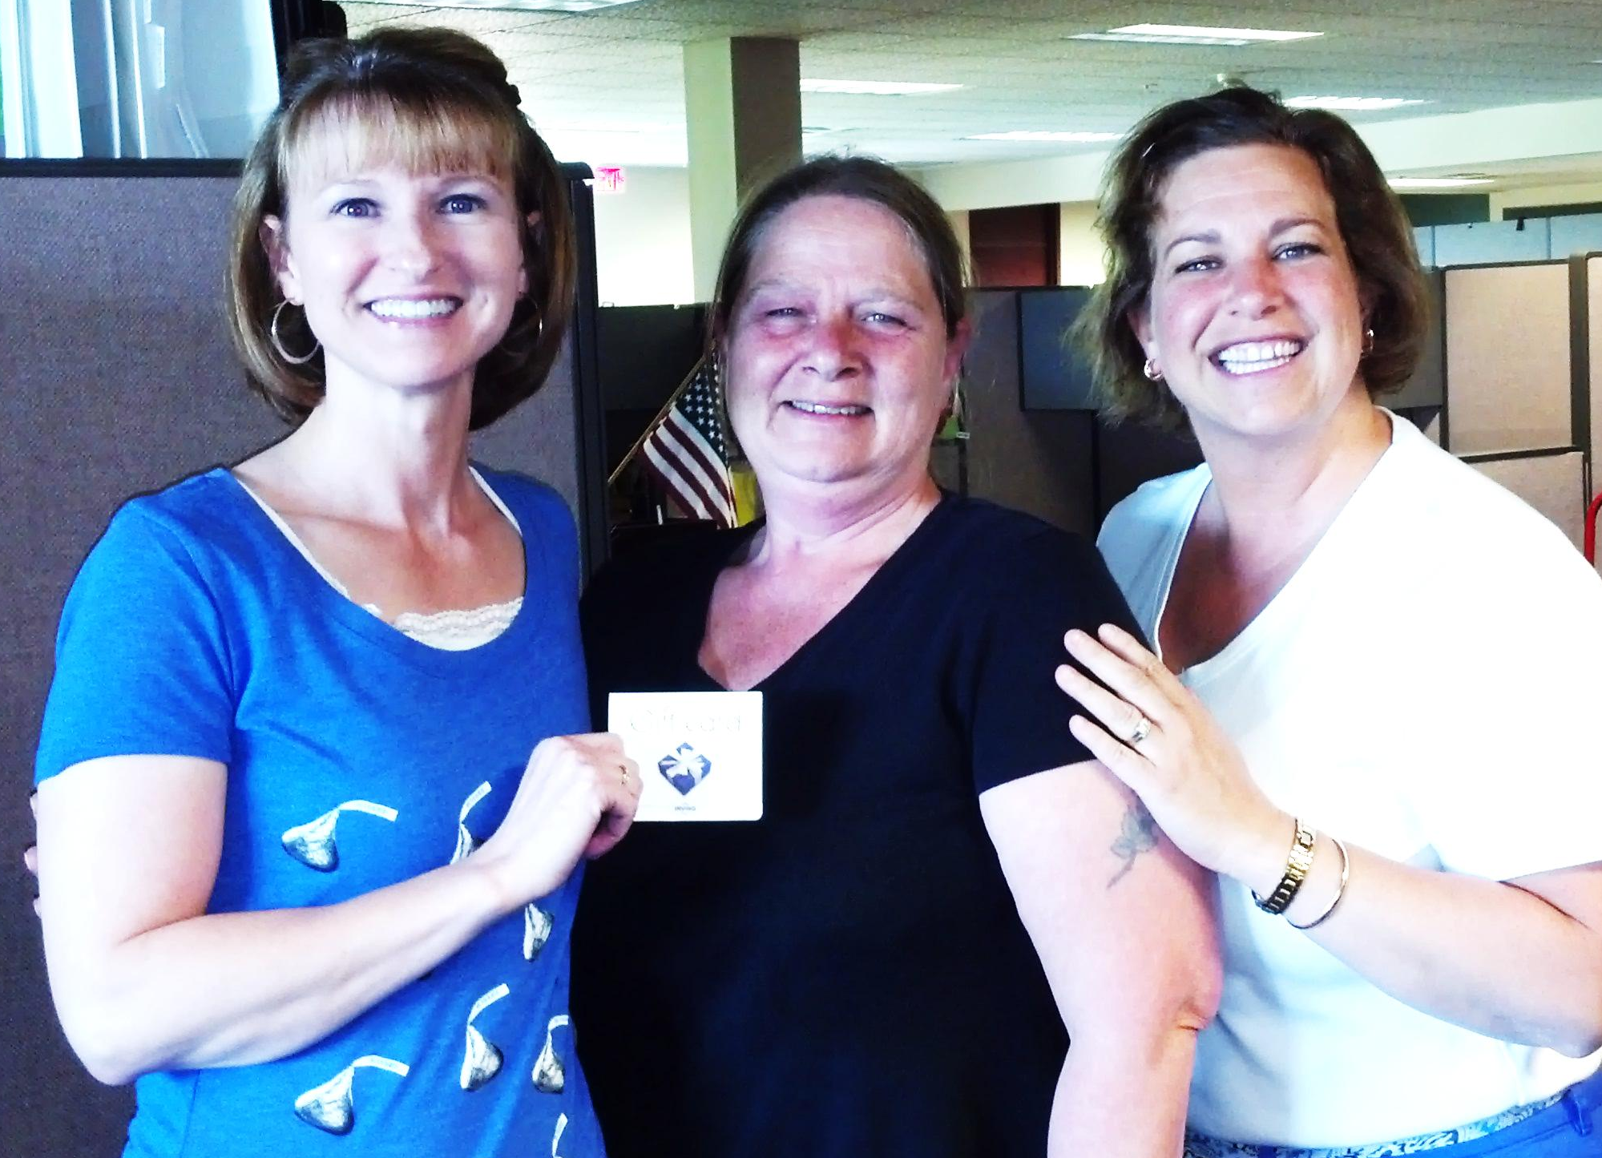

L to R: Julie Scala, Portland Council Group Rep, Donna Stevens, Renee Dugas, Portland Council Vice President

Enjoy the summer sun- but


The best preventative measures include limiting sun exposure, wearing UV blocking sun glasses, a wide brimmed hat, umbrella and appropriate sunscreen products. So be wise and you can still enjoy the outdoors.

Want to get involved?



Ronald McDonald House
250 Brackett St, Portland, Me
Schedule for 2013
Volunteers Welcome!
Please contact Christina Shea at
603 227 3557

2014 Dates & who’s Responsible
- July 14, 2014 – 5 Davis Farm Rd
- August 11, 2014 – Life Members
- September 8, 2014 – 45 Forest Ave
- October 13, 2014 – 5 Davis Farm Rd
- November 10, 2014 – 45 Forest Ave
- December 8, 2014 – Life Members

What’s going on in the Council’s?

Maine – Portland Council

Will be doing a collection of gently used Little League/ Softball/ Baseball equipment to send to the Dominican Republic. All are encouraged to donate uniforms, t-shirts, balls, bats, gloves. Look for collection receptacles in the lobby at 5 Davis Farm.


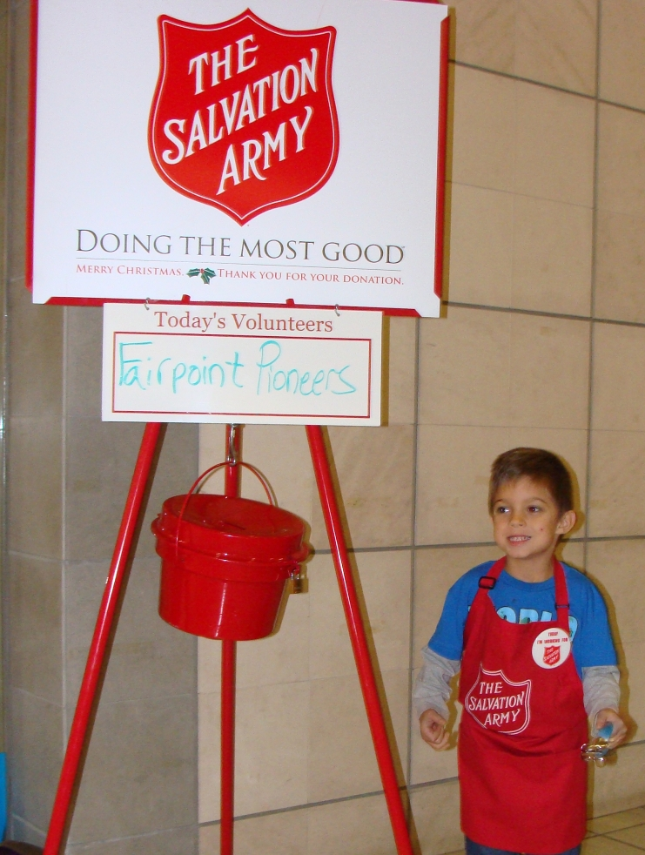

Troupons up Date
Many Many thanks to Julie Scala and her helpers for running this very worth while project. It was very very time consuming, but what a great way to help our Military families.
June 2014 Numbers
Category | Number of coupons | Value of coupons
Non-Food | 7,401 | $13,220.60
Food | 994 | $1,048.33
Baby | 233 | $292.10
Pet | 391 | $537.80
Totals | 9,019 | $15,098.83



Total 2014
Category | Number of coupons | Value of coupons
Non-Food | 80,527 | $150,801.36
Food | 39,263 | $39,080.42
Baby | 2,321 | $3,537.09
Pet | 4,590 | $6,974.83
Totals | 126,701 | $200,393.70

Packets sent: | 74

Several people have requested that I republish this poem. It gives us something to think about.

How we spend the dash!

I read of a man who stood to speak at a funeral of a friend.
He referred to the dates on her tombstone from the beginning to the end.
He noted that first came the date of her birth and read the following dates with tears.
But he said that what mattered most of all was the dash between those years.

For that dash represents all the time she spend while alive on earth
And now only those who loved her know what that little line is worth.
For it matters not how much we own: the cars, the house, the cash.
What matters is how we lived and love, and who we spend the dash.

So, think about it long and hard: Are there things you’d like to change?
For you never know how much time is left that can still be rearranged.
If we could just slow down enough to consider what’s true and real.
And always try to remember how other people feel.

And be less quick to anger, and show appreciation more.
And love the people of our lives the way we’ve never loved before.
If we treat each other with respect and more often wear a smile,
Remembering that this special dash may only last a little while.

So, when your eulogy’s read, with your life’s actions to re-hash,
Will you be proud of the things they say about how you spent your dash.

