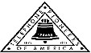 Jasper N. Keller Chapter #33
“Answering the call of those in need”
ISSUE 5, VOL. 7 July 2015

From the President’s desk…
I can not believe it is almost July and that means watermelon, parades, and fireworks…can’t wait. We will be camping, again! After all I keep telling myself I am retired….
My sister is here from Germany, it has been a fun and full week. Chatting about the “good old” days and of course, “do you remember” this or that….always good to catch up and remember where we came from.
Jenny, had her birthday this month…good grief 43, where oh where does the time go?
Pioneers have been busy with the distribution of the “sock it to me” kits. I still amaze me how many people have never heard about the Pioneers. Are we doing something wrong or something right…I say we are doing a lot of right, but just don’t broadcast it…maybe we should…

Concord “Pioneers” U8 Softball Teams wins again!

What a great bunch of girls….They have come a long way over the past 3 years….The Concord U8 girls’ softball team (shown above) won the Grip N’ Rip Invitational Tournament. The Concord FairPoint Pioneers went 3-0 in pool play on their way to a top seed heading into the elimination round. Rain shortened the field to four teams, and Concord beat Londonderry in the semifinal and went on to beat Barrington in the final. They play again July 10 – 13, once again in Barrington, at 126 Smoke St., if you are in the area please stop by and cheer them on. You can also see them in the Londonderry Old Home Days Parade.
Talking Book Repair – Help Needed!
Jim Dimick reports we are down to three people and we are looking for 2 more people. We meet Monday morning 8 am to 12 noon at the Dolloff Bldg. on the State Hospital Grounds. We test, repair and clean digital machines. We will start in Sept. as we take the months of July and August off. Any one interested can email me at ejdimick8@gmail.com or give me a call 603-228-1131. Thanks, Jim


Monthly Meeting Dates and Times for the Chapter, Council & Life Member Clubs Cont.

Southern NH LMC: Will have the following: Luncheons schedule for 2015 are as follows 9/17 & 12/10 Please note your calendars.... They will be held at the The Yard Restaurant in Manchester, NH. If you are not on the Luncheon list or know someone who should be please, contact Bill Macy at 603 890 1572.

Northern NH LMC: Dates for 2015 luncheons are as follows: Thursday, August 6th at 11:30 am at Makris Lobster & Steakhouse, Rte 106, Concord, NH. Thursday, October 8th at 11:30 am at Town and Country Motor Inn, Shelburne, NH. Please contact Rachel French at rfrench89@gmail.com for more information.

Vermont
Vermont LMC: Please contact Kay Hopkins for more information about 2015 up coming luncheons at 802-684-2124 (Res), 802-535-4702 (cell).

You can never have too many friends. Please ‘like’ us to keep up with what’s going on in the Jasper N. Keller Chapter #33. Here is the link to use for Facebook

https://www.facebook.com/pages/Pioneers-FairPoint-Jasper-N-Keller-Chapter-33/177159619001637?ref=hl

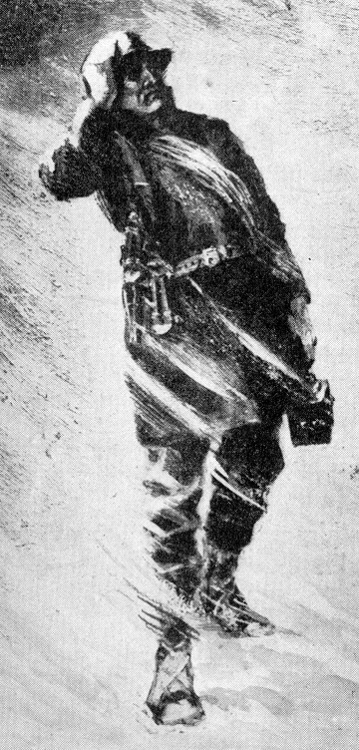

Monthly Meeting Dates and Times for the Chapter, Council & Life Member Clubs

Maine
Portland Council: Meets the 2nd Tuesday of each month from 9 am to 11 am at 1 Davis Farm Rd., Portland, Me. For details email: mainepioneers@fairpoint.com.

Bangor Life Member Club:
For more information please contact Cindy Black at eastport4the4th@msn.com.

Kennebec Life Member Club: Meets the last Wednesday of the month at 11:00 am alternately in Waterville or Augusta. Please contact Kathy Camann at 207-872-2355 or dkcamann@myfairpoint.net for locations or more information.
Portland Life Member Club: Meets the 2nd Thursday of each month at 11:30 am at Thatcher’s Restaurant, Foden Rd. S Portland, Me…Any retirees in the Portland area please come and join us.
New Hampshire
New Hampshire Council: Meets the 3rd Thursday of each month from 2 p.m. to 5 p.m. at 875 Holt Ave., Manchester, NH contact Pascale Coates for more details at 603 479 4718

Dover/Portsmouth LMC: Meets the 2nd Tuesday of each month starting at 11:30 am at Rogers Pizza at 869 Central Ave, Dover, NH. The spring luncheon will be June 9th, and the fall luncheon will be October 13th; both are at 11:30 at Granite Steak and Grill. Contact Kim Paradis for more details at 603 664 7744.

"Happy Feet and Minds" aka
"Sock it to me"


Update!
“Fun in the Sun” Manchester, NH

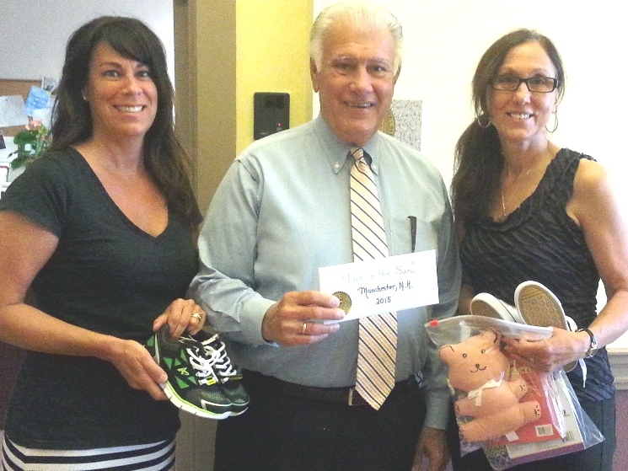
L to R: Brenda Dwyer, Mayor Gatsas, Kim Joseph

The NH Council also donated $450.00 to “Fun in the Sun” to purchase bathing suits, towels and sun screen for the children that can’t afford them. The program serves over 1,000 children over the course of the summer, 90% of these children come from low income families. There are 3 sites in Manchester.

My Turn – Manchester, NH and Rochester, NH

Books, socks and footwear were also donated to My Turn. This program works to keep children in school and to give them the skills that they need to get a job and be productive adults.

Want to get involved?





250 Brackett St, Portland, Me
Schedule for 2014
Volunteers Welcome!
Please contact Renee Dugas at
207-797-1635

Ronald McDonald Guest Chef

- July 13, 2015 – 5 Davis Farm Rd
- August 10, 2015 – 45 Forest Ave
- September 14, 2015 – Life Members
- October 12, 2015 – 5 Davis Farm Rd
- November 9, 2015 – 45 Forest Ave
- December 14, 2015 – Life Members


If you would like to donate food to be used at the evening meals please contact Renee Dugas at 207 317 6798 or Christina Shea at 207 233 9133.
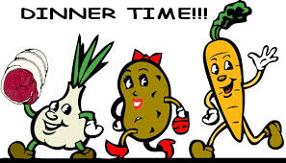

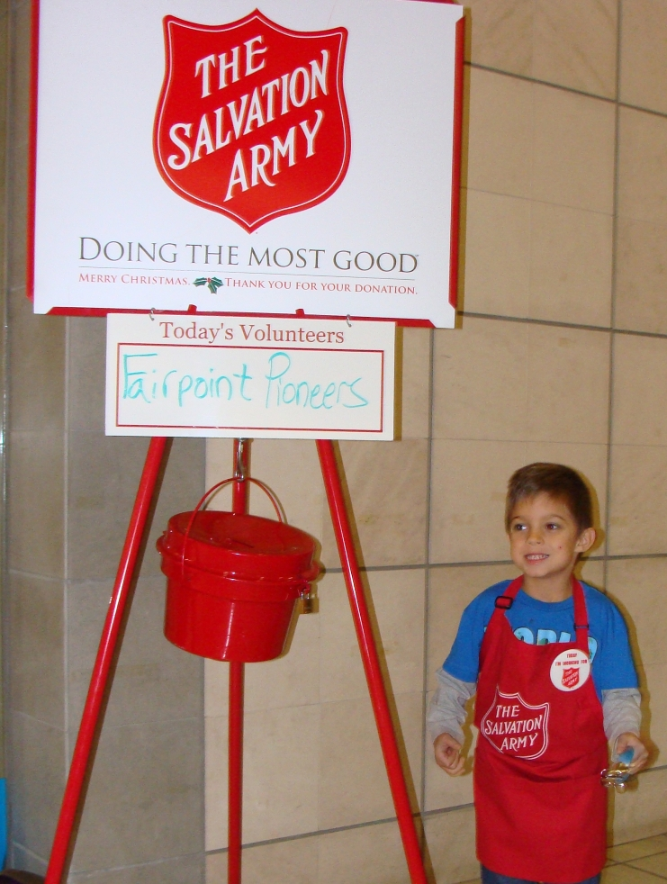
I have several request for this poem….

"Sock it to me" Cont.

Allenstown Elementary school – Allenstown, NH

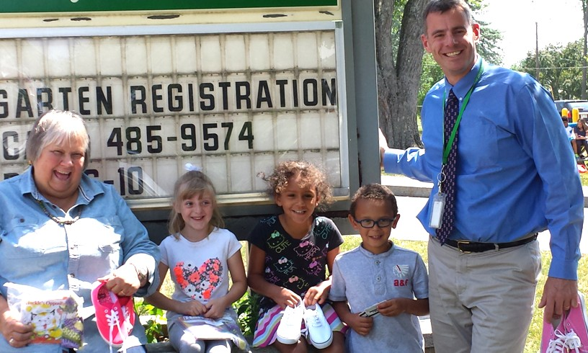
L to R: Mary Lefebvre, Morgan, Dannay, Nathan, Principal Anthony Blinn

Nashua Children’s Home, Nashua, NH

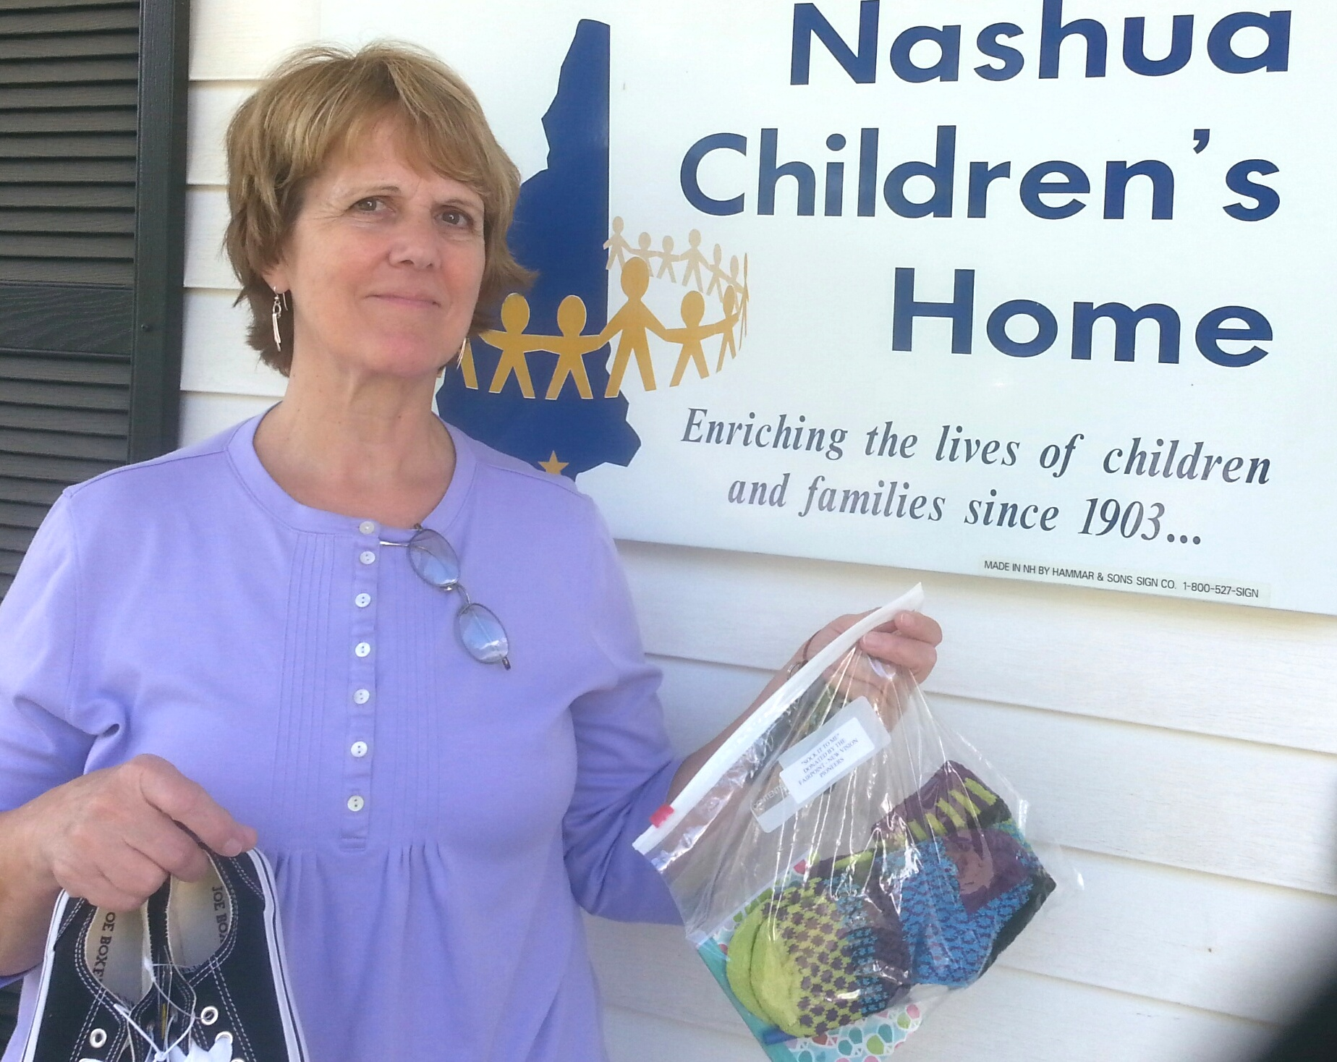
Lori Wilshire, Business Manager of Nashua Children’s Home. They were absolutely thrilled to receive the socks, books and sneakers.

American car horns beep in the tone of F.
American car horns beep in the tone of F.
No piece of paper can be folded more than 7 times.
Donkeys kill more people annually than plane crashes.
1 in every 4 Americans has appeared on television.
You burn more calories sleeping than you do watching television.
Oak trees do not produce acorns until they are fifty years of age or older.
The first product to have a bar code was Wrigley's gum.
The king of hearts is the only king without a mustache.
A Boeing 74 wingspan is longer than the Wright brother's first flight.
Venus is the only planet that rotates clockwise.
The first CD pressed in the US was Bruce Springsteen's "Born in the USA"
Apples, not caffeine, are more efficient at waking you up in the morning.
The 57 on the Heinz ketchup bottle represents the number of varieties of pickles the company once had.
The plastic things on the end of shoelaces are called "aglets."
Most dust particles in your house are made from dead skin.
The first owner of the Marlboro Company died of lung cancer.
Barbie's full name is Barbara Millicent Roberts.
Betsy Ross is the only real person to ever have been the head on a Piz dispenser.
Marilyn Monroe had six toes.
Walt Disney was afraid of mice.
The sound of EAT. Walking was made by someone squishing her hands in jelly.
Debra Winger (went to school with her) was the voice of EAT.
Pearls melt in vinegar.
Bill Clinton has been in 3 porno films from the waste down.
It takes 3,000 cows to supply the NFL with enough leather for a year's supply of footballs.
The three most valuable brand names on earth: Marlboro, Coca Cola, and Budweiser, in that order.
Average life span of a major league baseball: seven pitches.
A duck's quack doesn't echo and no one knows why.
Richard Millhouse Nixon was the first US president whose name contains all the letters from the word "criminal." The second? William Jefferson Clinton.
American car horns beep in the tone of F.
No piece of paper can be folded more than 7 times.
Donkeys kill more people annually than plane crashes.
1 in every 4 Americans has appeared on television.
You burn more calories sleeping than you do watching television.
Oak trees do not produce acorns until they are fifty years of age or older.
The first product to have a bar code was Wrigley's gum.
The king of hearts is the only king without a mustache.
A Boeing 747s wingspan is longer than the Wright brother's first flight.
Venus is the only planet that rotates clockwise.
The first CD pressed in the US was Bruce Springsteen's "Born in the USA"
Apples, not caffeine, are more efficient at waking you up in the morning.
The 57 on the Heinz ketchup bottle represents the number of varieties of pickles the company once had.
The plastic things on the end of shoelaces are called "aglets."
Most dust particles in your house are made from dead skin.
The first owner of the Marlboro company died of lung cancer.
Barbie's full name is Barbara Millicent Roberts.
Betsy Ross is the only real person to ever have been the head on a Pez dispenser.
Marilyn Monroe had six toes.
Walt Disney was afraid of mice.
The sound of E.T. walking was made by someone squishing her hands in jelly.
Debra Winger (went to school with her) was the voice of E.T.
Pearls melt in vinegar.
Bill Clinton has been in 3 porno films from the waste down.
It takes 3,000 cows to supply the NFL with enough leather for a year's supply of footballs.
The three most valuable brand names on earth: Marlboro, Coca Cola, and Budweiser, in that order.
Average life span of a major league baseball: seven pitches.
A duck's quack doesn't echo and no one knows why.
Richard Millhouse Nixon was the first US president whose name contains all the letters from the word "criminal." The second? William Jefferson Clinton.

American car horns beep in the tone of F.
No piece of paper can be folded more than 7 times.
Donkeys kill more people annually than plane crashes.
1 in every 4 Americans has appeared on television.
You burn more calories sleeping than you do watching television.
Oak trees do not produce acorns until they are fifty years of age or older.
The first product to have a bar code was Wrigley's gum.
The king of hearts is the only king without a mustache.
A Boeing 747s wingspan is longer than the Wright brother's first flight.
Venus is the only planet that rotates clockwise.
The first CD pressed in the US was Bruce Springsteen's "Born in the USA"
Apples, not caffeine, are more efficient at waking you up in the morning.
The 57 on the Heinz ketchup bottle represents the number of varieties of pickles the company once had.
The plastic things on the end of shoelaces are called "aglets."
Most dust particles in your house are made from dead skin.
The first owner of the died of lung cancer.
Barbie's full name is Barbara Millicent Roberts.
Betsy Ross is the only real person to ever have been the head on a Pez dispenser.
Marilyn Monroe had six toes.
Walt Disney was afraid of mice.
The sound of E.T. walking was made by someone squishing her hands in jelly.
Debra Winger (went to school with her) was the voice of E.T.
Pearls melt in vinegar.
Bill Clinton has been in 3 porno films from the waste down.
It takes 3,000 cows to supply the NFL with enough leather for a year's supply of footballs.
The three most valuable brand names on earth: Marlboro, Coca Cola, and Budweiser, in that order.
Average life span of a major league baseball: seven pitches.
A duck's quack doesn't echo and no one knows why.
Richard Millhouse Nixon was the first US president whose name contains all the letters from the word "criminal." William Jefferson Clinton.

a

e

