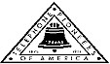 Jasper N. Keller Chapter #33
“Answering the call of those in need”
ISSUE 3, VOL. 6 June 2014

From the President’s desk…
Well, here it is more than half way through the month of June and I still don’t have the news letter out! Way too much on my plate..So, today is the day to finish it and it get out. Things are booming in Keller Chapter land…we have had a few Annual Membership Appeals; the sad thing is that when we were bought by FairPoint, FairPoint couldn’t continue to take out dues. Sooo, we have had to resign all the active members again….and to make matters worse, “they” can’t just sign a form and we send it to accounting…of course not! “They” can pay their dues for a year or go into Cyber grants and have payroll deductions….From what I understand that is a real nightmare….But I do have a Square, that I can swipe a debit/credit card….makes life a whole of a lot easier. I want to thank Joy Randlett for the great work she has done with the Face Book page….if you haven’t seen it please, go and check it out. The link is at the end of the news letter. Thanks Joy! And we now have a website…http://www.newvision-kellerpioneers.org/. If there is something that you would like to see on either Face Book or the website please let me know. Richard and I have been camping twice so far this year…always good to get away, but than again it is good to come home. Have a happy and safe summer!

COINS LEFT ON TOMBSTONES
While visiting some cemeteries you may notice that headstones marking certain graves have coins on them.
These coins have distinct meanings when left on the headstones of those who gave their life while serving in America's military.
A coin left on a headstone is meant as a message to the deceased soldier's family that someone else has visited the grave to pay respect. Leaving a penny at the grave means simply that you visited.
A nickel indicates that you and the deceased trained at boot camp together, while a dime means you served with him in some capacity. By leaving a quarter at the grave, you are telling the family that you were with the solider when he was killed.
The money left at graves in national cemeteries and state veterans cemeteries is collected, and put towards maintaining the cemetery or paying burial costs for indigent veterans.
In the US, this practice became common during the Vietnam War, due to the political divide in the country over the war; leaving a coin was seen as a more practical way to communicate that you had visited the grave than contacting the soldier's family, which could devolve into an uncomfortable argument over politics relating to the war.

Some Vietnam veterans would leave coins as a "down payment" to buy their fallen comrades a beer or play a hand of cards when they would finally be reunited.
The tradition of leaving coins on the headstones of military men and women can be traced to as far back as the Roman Empire.
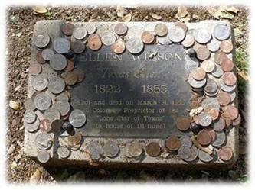

Calendar of upcoming Events – Mark your calendars
Portland Council

New Hampshire Council

Monthly Meeting Dates and Times for the Chapter, Council & Life Member Clubs Cont.

Southern NH LMC: Will have the following: Luncheons schedule for 2014: Sept. 25th & December 11th (turkey dinner). They will be held at the The Yard Restaurant in Manchester, NH. If you are not on the Luncheon list or know someone who should be please contact Bill Macy at 603 890 1572.

Northern NH LMC: Dates for 2014 luncheons will be coming out soon. Please contact Rachel French at rfrench89@gmail.com for more information.

Vermont
Vermont LMC: Dates for the 2014 luncheons will be coming out soon. Please contact Kay Hopkins for more information at 802-684-2124 (house), 802-535-4702 (cell).

You can never have too many friends. Please ‘like’ us to keep up with what’s going on in the Jasper N. Keller Chapter #33. Here is the link to use for Facebook

https://www.facebook.com/pages/Pioneers-FairPoint-Jasper-N-Keller-Chapter-33/177159619001637?ref=hl

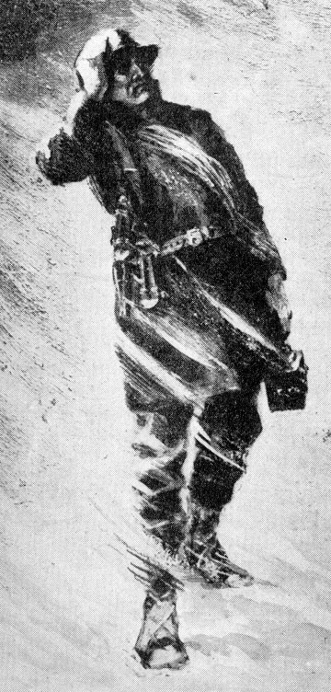

Monthly Meeting Dates and Times for the Chapter, Council & Life Member Clubs

Maine
Portland Council: Meets the 2nd Tuesday of each month from 9 am to 11 am at 1 Davis Farm Rd., Portland, Me. Contact Christina Shea for more details at: mainepioneers@fairpoint.com.

Bangor Life Member Club:
For more information please contact Cindy Black at eastport4the4th@msn.com.

Kennebec Life Member Club: Meets the last Wednesday of the month at 11:00 am alternately in Waterville or Augusta. Please contact Kathy Camann at 207-872-2355 or dkcamann@myfairpoint.net for locations or more information.
Portland Life Member Club: Meets the 2nd Thursday of each month at 11:30 am at Thatcher’s Restaurant, Foden Rd. S Portland, Me…Any retirees in the Portland area please come and join us.

New Hampshire

New Hampshire Council: Meets the 3rd Tuesday of each month from 3 p.m. to 6 p.m. at 875 Holt Ave., Manchester, NH contact Pascale Coates for more details at 603 479 4718

Dover/Portsmouth LMC: Meets the 2nd Tuesday of each month starting at 11:30 am at Rogers Pizza at 869 Central Ave, Dover, NH. Contact Kim Paradis for more details at 603 664 7744

Coins left on tombstones Cont.
Some Vietnam veterans would leave coins as a "down payment" to buy their fallen comrades a beer or play a hand of cards when they would finally be reunited. The tradition of leaving coins on the headstones of military men and women can be traced to as far back as the Roman Empire.
Pioneers Volunteering
.
The Jasper N Keller Chapter recently held the annual spring clean up of Northwood Meadows State Park. We did everything from cutting down trees, picking up trash, painting the “potty”, cleaning winter debris from the pond and book. Kim Paradis reported. Anyone interested in volunteering should call Kim Paradis at (603) 781-3462 (cell number) or email her at kimaparadis@metrocast.net for more information.

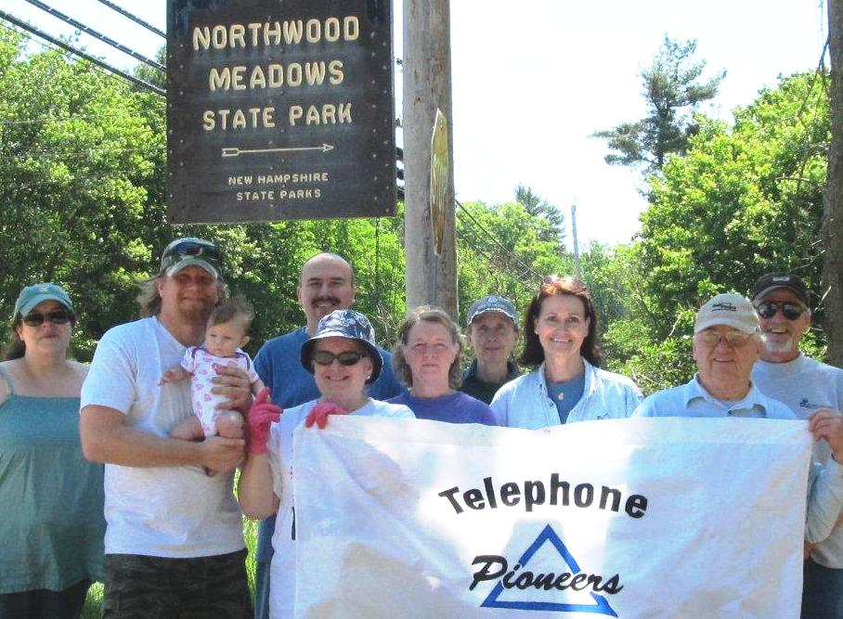

Want to get involved?



Ronald McDonald House
250 Brackett St, Portland, Me
Schedule for 2013
Volunteers Welcome!
Please contact Christina Shea at
603 227 3557

2014 Dates & who’s Responsible
- July 14, 2014 – 5 Davis Farm Rd
- August 11, 2014 – 45 Forest Ave
- September 8, 2014 – Life Members
- October 13, 2014 – 5 Davis Farm Rd
- November 10, 2014 – 45 Forest Ave
- December 8, 2014 – Life Members

What’s going on in the Council’s?

Maine – Bangor Council
Bangor Area Homeless Shelter running out of food. The Bangor Council will be collecting items such as canned soup, canned vegetables, peanut butter, cereal and pasta now through the end of May.

Maine – Portland Council
Please, please consider purchasing items for our June when you are at the grocery store. Drop off boxes at 1 & 5 Davis Farm Rd.
Portland Council is collecting gently used Little League/Softball/Baseball equipment to send to the Dominican Republic. All are encouraged to donate uniforms, T-shirts, balls, bats and gloves.

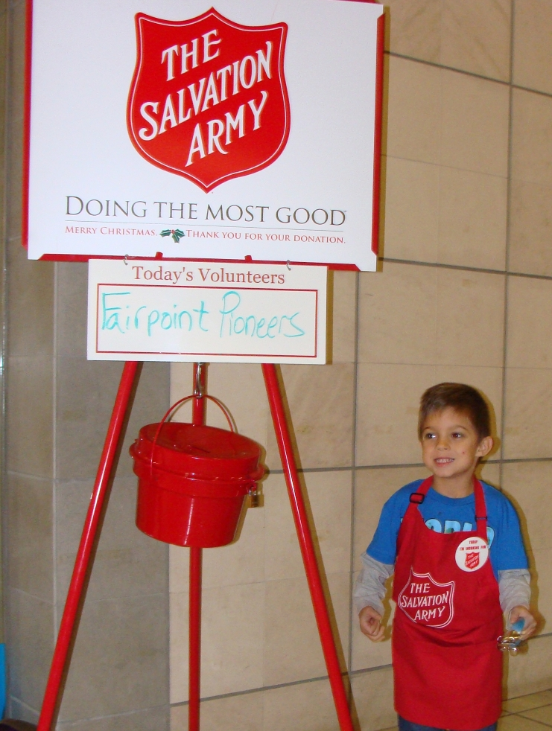

Troupons up Date
Will you help? If you would like to donate coupons please send them to Julie Scala, 5 Davis Farm Rd., Portland, ME 04103

May 2014 Numbers
Category | Number of coupons | Value of coupons
Non-Food | 15,742 | $27,762.79
Food | 6,274 | $5,916.06
Baby | 480 | $722.85
Pet | 884 | $1,289.77
Totals | 23,380 | $35,691.47



What’s going on in the Council’s? cont.

New Hampshire Council
We Need a Secretary!
How about you? The NH Council is in need of a secretary and some other help. If you’d like to join and help out, please contact Maureen Fogg - Vice President at Maureen.Fogg@fairpoint.com or Pascale Coates - President at Pascale.Coates@fairpoint.com

Bryant Pond – Yank the crank!
Bryant Pond would be a dot on the map, if it were not for one curious fact: this little way station happens to be the home of the last crank-telephone system in the U.S. Somewhere in the modest stillness of Bryant Pond, someone rotates a crank, jangling the bell on the call box and generating enough current to cause a tab with the caller's number to click down on the switchboard in the pine-paneled back room of Elden Hathaway's house, also known as the Bryant Pond Telephone Co. One of the two operators responds to the caller, voice to voice, and makes the requested connection by hand. If nobody picks up the phone, she will report "d.a." (doesn't answer). Although nearly half of the 434 customers now have private phones, the party line is still a distinctive part of the crank system. As many as 23 customers have been known to share a single line. Courtesy requires that a party-liner give a little ring when signing off to notify the others that the line is clear. In one day this homey and tenuous network tore apart, and the town with it, when the new owner, the Oxford County Telephone & Telegraph Co., announced it was replacing crank with dial. Before you could say D.A., a "Don't Yank the Crank" committee was formed. A petition was posted at the Village Store and a meeting was held. A poll found that 72 percent of subscribers contacted wanted to stay with the crank system. Only 10 percent wanted dial. In 1983 the sale did go through and the crank was yanked!
