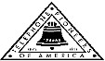 Jasper N. Keller Chapter #33
“Answering the call of those in need”
ISSUE 5, VOL. 6 June 2015

From the President’s desk…
Summer is almost here! After a long and cold winter we are excited to be getting out in the sun and having fun. Are you ready for it?
I am so thankful for the rain; the pollen was starting to get to me…. On Saturday, past, I helped my daughter and friends do a yard sale for the 2015 Boston Marathon® Jimmy Fund Walk on September 27. The route they use for the walk is the Boston Marathon route. This will be the 5th year her team has participated. You know what they say “one mans trash is another mans treasure”….yikes so true.
Richard and I have been camping already. We went to VT, in April and can you believe that people were still skiing at Cannon. Two weeks is a long time to be away from the office, than for the next week it’s catch up time. We don’t go again until the end of June, for 4th of July.
My sister arrives from Germany, for her yearly trip to the homeland, on June 22nd. That is always a whirlwind tour here, before she goes to Maine.
I have been working hard to get to office set up once again. The real estate people found an old “trolley” that was used to reach mid span splices before bucket trucks….that is now hanging on a cable from the wall…very neat….One of the IT men is going to get a telephone pole to attach it to…he thought it would look more realistic…cool! Also, I have been working on getting pictures hung and awards placed.
Hope everyone has a save and enjoyable summer…..




Special Olympics Summer Games
June 6th & 7th
For sandwich making and Olympic Town
- Contact Kim Paradis 603 664 7744



Betty Hackett needs volunteers on Saturday June 6th for the standing and running long jump
- Contact Betty Hackett 603 267 8888



Northwood Meadows Pioneer State Park
Spring clean up and sprucing up
June 13th starting at 8:30 am
- Contact Kim Paradis 603 664 7744

Monthly Meeting Dates and Times for the Chapter, Council & Life Member Clubs Cont.

Southern NH LMC: Will have the following: Luncheons schedule for 2015 are as follows 9/17 & 12/10 Please note your calendars.... They will be held at the The Yard Restaurant in Manchester, NH. If you are not on the Luncheon list or know someone who should be please, contact Bill Macy at 603 890 1572.

Northern NH LMC: Dates for 2015 luncheons will be coming out soon. Please contact Rachel French at rfrench89@gmail.com for more information.

Vermont
Vermont LMC: Please contact Kay Hopkins for more information about 2015 up coming luncheons at 802-684-2124 (Res), 802-535-4702 (cell).

You can never have too many friends. Please ‘like’ us to keep up with what’s going on in the Jasper N. Keller Chapter #33. Here is the link to use for Facebook

https://www.facebook.com/pages/Pioneers-FairPoint-Jasper-N-Keller-Chapter-33/177159619001637?ref=hl

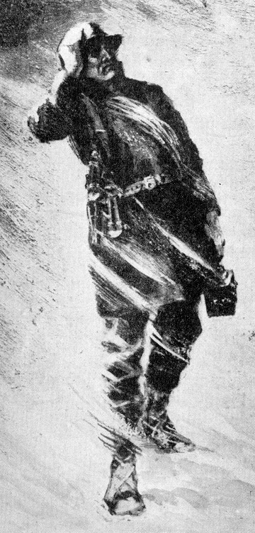

Monthly Meeting Dates and Times for the Chapter, Council & Life Member Clubs

Maine
Portland Council: Meets the 2nd Tuesday of each month from 9 am to 11 am at 1 Davis Farm Rd., Portland, Me. For details email: mainepioneers@fairpoint.com.

Bangor Life Member Club:
For more information please contact Cindy Black at eastport4the4th@msn.com.

Kennebec Life Member Club: Meets the last Wednesday of the month at 11:00 am alternately in Waterville or Augusta. Please contact Kathy Camann at 207-872-2355 or dkcamann@myfairpoint.net for locations or more information.
Portland Life Member Club: Meets the 2nd Thursday of each month at 11:30 am at Thatcher’s Restaurant, Foden Rd. S Portland, Me…Any retirees in the Portland area please come and join us.
New Hampshire
New Hampshire Council: Meets the 3rd Thursday of each month from 2 p.m. to 5 p.m. at 875 Holt Ave., Manchester, NH contact Pascale Coates for more details at 603 479 4718

Dover/Portsmouth LMC: Meets the 2nd Tuesday of each month starting at 11:30 am at Rogers Pizza at 869 Central Ave, Dover, NH. The spring luncheon will be June 9th, and the fall luncheon will be October 13th; both are at 11:30 at Granite Steak and Grill. Contact Kim Paradis for more details at 603 664 7744.

Summer Quiz!

1. What is the collective name of a group of seventeen hundred islands between Canada and the USA which are popular summer resorts?
2. Whose summer villa is at Castel Gandolfo?
3. When is the Christian festival of Midsummer Day?
4. Where were the 1968 Summer Olympics held?
5. What is used as the filling of a summer pudding?
6. Which institution, introduced by Harold Wilson, consists of TV and radio lectures and summer schools?
7. In 'Alice's Adventures in Wonderland', what was done all on a summer's day?
8. Elvis Presley was the King, Bruce Springsteen the Boss. What nickname was given to Donna Summer?
9. In which capital city in the Northern Hemisphere, the name of which is a local tribe, has almost 19 hours of daylight during the summer solstice?
10. Which actor, later to find fame in 'It Ain't Half Hot Mum', played the part of one of Cliff Richard's friends in the film 'Summer Holiday'?
11. Which brothers wrote the song summertime?
12. Esther Summerson is the heroine of which novel by Charles Dickens?
13. Which duo had a hit in 1978 with Summer Nights?
14. Which hit song describes summer thus? Those days of soda and pretzels and beer?
Want to get involved?





250 Brackett St, Portland, Me
Schedule for 2014
Volunteers Welcome!
Please contact Renee Dugas at
207-797-1635

Ronald McDonald Guest Chef

- June 8, 2015 – Life Members
- July 13, 2015 – 5 Davis Farm Rd
- August 10, 2015 – 45 Forest Ave
- September 14, 2015 – Life Members
- October 12, 2015 – 5 Davis Farm Rd
- November 9, 2015 – 45 Forest Ave
- December 14, 2015 – Life Members


If you would like to donate food to be used at the evening meals please contact Renee Dugas at 207 317 6798 or Christina Shea at 207 233 9133.
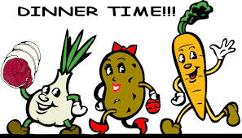

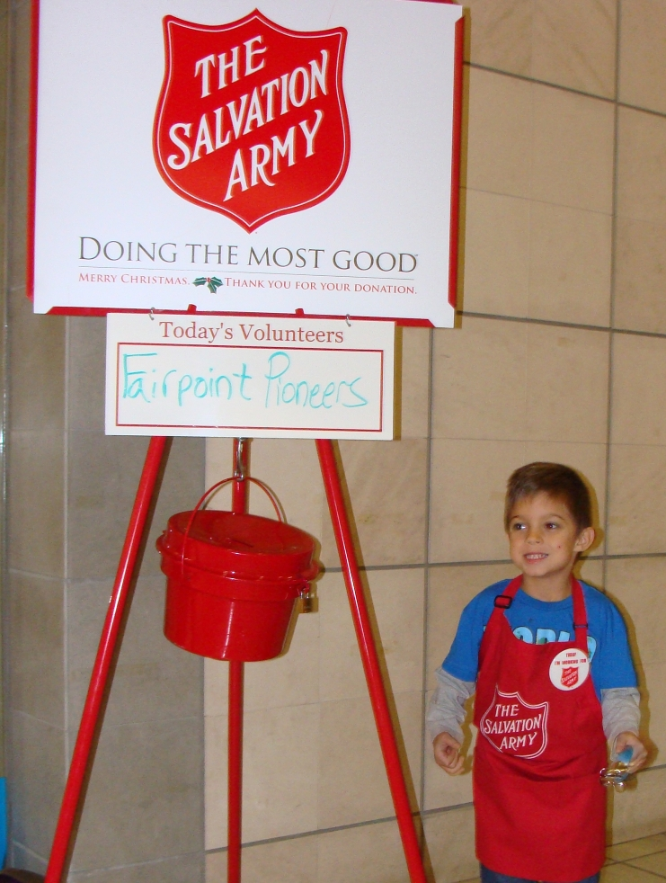

"Happy Feet and Minds" aka
"Sock it to me"



The Keller Chapter is participating in the New Vision Pioneer Spring/Summer project. The Keller Chapter received $2,000.00 from a grant from the Pioneer Foundation. We will be providing books, socks and shoes to Pre K summer schools in the Chapter area. We will also volunteer to read to the students. If you are interested in helping please contact the Pioneer office at 603 656 8066.
Softball Champs
The Concord, NH U8 softball team won the Russ Monbleau Memorial Tournament of Memorial Day weekend in Londonderry. In the U8 division, the Concord, NH FairPoint Pioneers started out 3 – 0 in pool play with excellent defense, allowing only 6 runs. They went on to beat Barrington, NH in the Championship, 10 – 4 and earn a bid to the national tournament in Newberry, Fl. The Concord, NH U8 team is sponsored by the Jasper N Keller Chapter and the NH Council. It was a great time and all the girls were super players.
ANSWERS
1. Thousand islands
2. The pope
3. 24th June
4. Mexico
5. Soft fruit (such as raspberries or blackcurrants)
6. Open University
7. Queen of Hearts made some tarts
8. Queen of Disco
9. Helsinki (Finland)
10. Melvyn Hayes
11. George & Ira Gershwin
12. Bleak House
13. John Travolta & Olivia Newton John
14. Lazy Hazy Crazy Days of summer

Keep Food Safe when Grilling
- Wash hands with hot, soapy water before and after handling food.
- Keep food and drinks in separate coolers.
- Never leave perishable food out of the refrigerator for more than two hours. When the air temperature is above 90°, do not leave food out for more than one hour.
- Use clean utensils and dishes to serve food. Each dish should have its own serving utensils to avoid cross-contamination.
- Preheat cooking grills for 20-30 minutes before using.
- Allow meat to completely thaw in a refrigerator before placing on a grill.
- Marinate meat in a tightly sealed plastic container or sealable plastic bag, and keep refrigerated until ready to use. Do not reuse marinade.
- Use a meat thermometer to ensure meats have reached a safe, internal temperature: hamburger-160°; chicken-165°; pork-150°; steak-145°; hot dogs-140°.
- Serve grilled foods on a clean dish, not a dish used for raw meat.
- Leftovers should be refrigerated or placed in a cooler within one hour after use.

Stay Protected from the Sun
- UV rays are weakest before 11 a.m. and after 4 p.m. Plan activities during these times.
- Skin does not have to feel hot to get burned, so protect yourself even on cloudy days.
- Wear sunscreen with a sun protection factor (SPF) of 15 or greater, and apply at least 20-30 minutes before going outside.
- Wear UVA/UVB protective sunglasses, and a hat.
- Stay hydrated by drinking plenty of water and juice. Alcohol consumption may cause dehydration.
- Protect your arms and legs with loose fitting, tightly woven cotton clothing.

American car horns beep in the tone of F.
American car horns beep in the tone of F.
No piece of paper can be folded more than 7 times.
Donkeys kill more people annually than plane crashes.
1 in every 4 Americans has appeared on television.
You burn more calories sleeping than you do watching television.
Oak trees do not produce acorns until they are fifty years of age or older.
The first product to have a bar code was Wrigley's gum.
The king of hearts is the only king without a mustache.
A Boeing 74 wingspan is longer than the Wright brother's first flight.
Venus is the only planet that rotates clockwise.
The first CD pressed in the US was Bruce Springsteen's "Born in the USA"
Apples, not caffeine, are more efficient at waking you up in the morning.
The 57 on the Heinz ketchup bottle represents the number of varieties of pickles the company once had.
The plastic things on the end of shoelaces are called "aglets."
Most dust particles in your house are made from dead skin.
The first owner of the Marlboro Company died of lung cancer.
Barbie's full name is Barbara Millicent Roberts.
Betsy Ross is the only real person to ever have been the head on a Piz dispenser.
Marilyn Monroe had six toes.
Walt Disney was afraid of mice.
The sound of EAT. Walking was made by someone squishing her hands in jelly.
Debra Winger (went to school with her) was the voice of EAT.
Pearls melt in vinegar.
Bill Clinton has been in 3 porno films from the waste down.
It takes 3,000 cows to supply the NFL with enough leather for a year's supply of footballs.
The three most valuable brand names on earth: Marlboro, Coca Cola, and Budweiser, in that order.
Average life span of a major league baseball: seven pitches.
A duck's quack doesn't echo and no one knows why.
Richard Millhouse Nixon was the first US president whose name contains all the letters from the word "criminal." The second? William Jefferson Clinton.
American car horns beep in the tone of F.
No piece of paper can be folded more than 7 times.
Donkeys kill more people annually than plane crashes.
1 in every 4 Americans has appeared on television.
You burn more calories sleeping than you do watching television.
Oak trees do not produce acorns until they are fifty years of age or older.
The first product to have a bar code was Wrigley's gum.
The king of hearts is the only king without a mustache.
A Boeing 747s wingspan is longer than the Wright brother's first flight.
Venus is the only planet that rotates clockwise.
The first CD pressed in the US was Bruce Springsteen's "Born in the USA"
Apples, not caffeine, are more efficient at waking you up in the morning.
The 57 on the Heinz ketchup bottle represents the number of varieties of pickles the company once had.
The plastic things on the end of shoelaces are called "aglets."
Most dust particles in your house are made from dead skin.
The first owner of the Marlboro company died of lung cancer.
Barbie's full name is Barbara Millicent Roberts.
Betsy Ross is the only real person to ever have been the head on a Pez dispenser.
Marilyn Monroe had six toes.
Walt Disney was afraid of mice.
The sound of E.T. walking was made by someone squishing her hands in jelly.
Debra Winger (went to school with her) was the voice of E.T.
Pearls melt in vinegar.
Bill Clinton has been in 3 porno films from the waste down.
It takes 3,000 cows to supply the NFL with enough leather for a year's supply of footballs.
The three most valuable brand names on earth: Marlboro, Coca Cola, and Budweiser, in that order.
Average life span of a major league baseball: seven pitches.
A duck's quack doesn't echo and no one knows why.
Richard Millhouse Nixon was the first US president whose name contains all the letters from the word "criminal." The second? William Jefferson Clinton.

American car horns beep in the tone of F.
No piece of paper can be folded more than 7 times.
Donkeys kill more people annually than plane crashes.
1 in every 4 Americans has appeared on television.
You burn more calories sleeping than you do watching television.
Oak trees do not produce acorns until they are fifty years of age or older.
The first product to have a bar code was Wrigley's gum.
The king of hearts is the only king without a mustache.
A Boeing 747s wingspan is longer than the Wright brother's first flight.
Venus is the only planet that rotates clockwise.
The first CD pressed in the US was Bruce Springsteen's "Born in the USA"
Apples, not caffeine, are more efficient at waking you up in the morning.
The 57 on the Heinz ketchup bottle represents the number of varieties of pickles the company once had.
The plastic things on the end of shoelaces are called "aglets."
Most dust particles in your house are made from dead skin.
The first owner of the died of lung cancer.
Barbie's full name is Barbara Millicent Roberts.
Betsy Ross is the only real person to ever have been the head on a Pez dispenser.
Marilyn Monroe had six toes.
Walt Disney was afraid of mice.
The sound of E.T. walking was made by someone squishing her hands in jelly.
Debra Winger (went to school with her) was the voice of E.T.
Pearls melt in vinegar.
Bill Clinton has been in 3 porno films from the waste down.
It takes 3,000 cows to supply the NFL with enough leather for a year's supply of footballs.
The three most valuable brand names on earth: Marlboro, Coca Cola, and Budweiser, in that order.
Average life span of a major league baseball: seven pitches.
A duck's quack doesn't echo and no one knows why.
Richard Millhouse Nixon was the first US president whose name contains all the letters from the word "criminal." William Jefferson Clinton.

a

e

