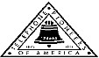 Jasper N. Keller Chapter #33
“Answering the call of those in need”
ISSUE 5, VOL. 4 May 2015

From the President’s desk…
Ah! Spring....can it be true? It was a long, cold and dreary winter. It is time to clean out my gardens and put out the watering hoses. wash windows, clean screens and get the outdoor furniture out. There is nothing like sitting in the sun in the early morning and sipping on a cup of coffee. Hearing the birds calling each other and chipmunks warning of approaching danger from a stray cat or other intruder. Last but not least, check out the camper for winter damage, or the dreaded mice. We only had two cracked vents from the ice storm...easily fixed.
There are so many changes at the National level, it is almost more than I can keep up with. What information needs to be down loaded to Councils and Life Member Clubs and what is just for information only. The National Board of Directors decided last September not to pay for any office help, since the Pioneers are a volunteer organization. I "volunteer" approximately 40 plus hours a week. It, however, is what needs to be done. I am concerned about what road the Pioneers are headed down. Will we continue to survive and help our communities or will we go the way of the dinosaur? A hundred and four years of fellowship, service and loyalty has stood the test of time, I believe we will survive and continue our volunteer projects, by "Answering the Call of those in need".
Look what's new for the Keller Chapter!
Pioneers are proud to announce their FREE New Vision Group APP. It is available for download to your Android or Apple smartphones.
Simply go to the Google Store app on your Android or Apple phone and search for New Vision Pioneers.
Download and open the APP to have easy access to Jasper N Keller Chapter #33 Pioneers stories, offers and other important information. Check it out!
*************************************
Can you help - Dover/Portsmouth LMC

- Riverside Nursing Home - May 11th at 1:30 pm. Baked goods are needed.
  - Contact Kim Paradis 603 664 7744
- Special Olympics Summer Games - June 4th - June 6th.
  - Contact Kim Paradis 603 664 7744
- Northwood Meadows Pioneer State Park - June 13th starting at 8:30 am
  - Contact Kim Paradis 603 664 7744



Monthly Meeting Dates and Times for the Chapter, Council & Life Member Clubs Cont.

Southern NH LMC: Will have the following: Luncheons schedule for 2015 are as follows 5/21, 9/17 & 12/10 Please note your calendars.... They will be held at the The Yard Restaurant in Manchester, NH. If you are not on the Luncheon list or know someone who should be please, contact Bill Macy at 603 890 1572.

Northern NH LMC: Dates for 2015 luncheons will be coming out soon. Please contact Rachel French at rfrench89@gmail.com for more information.

Vermont
Vermont LMC: Please contact Kay Hopkins for more information about 2015 up coming luncheons at 802-684-2124 (Res), 802-535-4702 (cell).

You can never have too many friends. Please ‘like’ us to keep up with what’s going on in the Jasper N. Keller Chapter #33. Here is the link to use for Facebook

https://www.facebook.com/pages/Pioneers-FairPoint-Jasper-N-Keller-Chapter-33/177159619001637?ref=hl

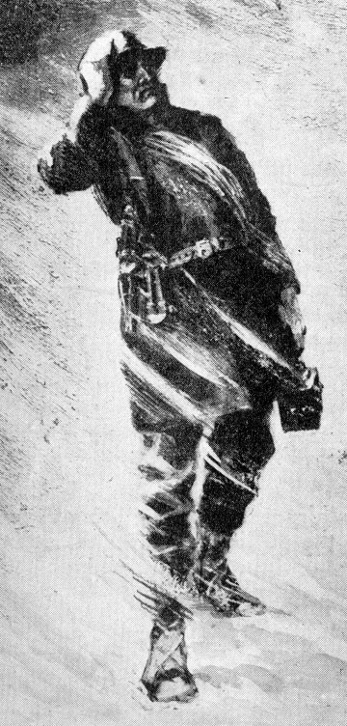

Monthly Meeting Dates and Times for the Chapter, Council & Life Member Clubs

Maine
Portland Council: Meets the 2nd Tuesday of each month from 9 am to 11 am at 1 Davis Farm Rd., Portland, Me. Contact Christina Shea for more details at: mainepioneers@fairpoint.com.

Bangor Life Member Club:
For more information please contact Cindy Black at eastport4the4th@msn.com.
Kennebec Life Member Club: Meets the last Wednesday of the month at 11:00 am alternately in Waterville or Augusta. Please contact Kathy Camann at 207-872-2355 or dkcamann@myfairpoint.net for locations or more information.
Portland Life Member Club: Meets the 2nd Thursday of each month at 11:30 am at Thatcher’s Restaurant, Foden Rd. S Portland, Me…Any retirees in the Portland area please come and join us.

New Hampshire
New Hampshire Council: Meets the 3rd Thursday of each month from 2 p.m. to 5 p.m. at 875 Holt Ave., Manchester, NH contact Pascale Coates for more details at 603 479 4718

Dover/Portsmouth LMC: Meets the 2nd Tuesday of each month starting at 11:30 am at Rogers Pizza at 869 Central Ave, Dover, NH. The spring luncheon will be June 9th, and the fall luncheon will be October 13th; both are at 11:30 at Granite Steak and Grill. Contact Kim Paradis for more details at 603 664 7744.

E.B. Dodds Fund Grant

The Keller Chapter is grateful for the insight of Earl Dodds to leave a substantial portion of his estate to the Telephone Pioneers of America upon his death in July of 1983; with the understanding that it would be used for the promotion of Community service activities. These wishes have been conveyed by the Portland Council and the New Hampshire Council. I feel that Mr. Dodd’s would approve with these choices.
Kits for Kidz, hygiene kits, were distributed to the Allenstown NH Elementary School by Joy Randlett and Mary Lefebvre.


L to R: Mr. Blinn, principal, Chloe, Oliver, Ms. Marilyn, school nurse

Kim Joseph delivered child hygiene kits to Pennichuck Middle School in Nashua. She also delivered the young adult hygiene kits to Weston School in Manchester.

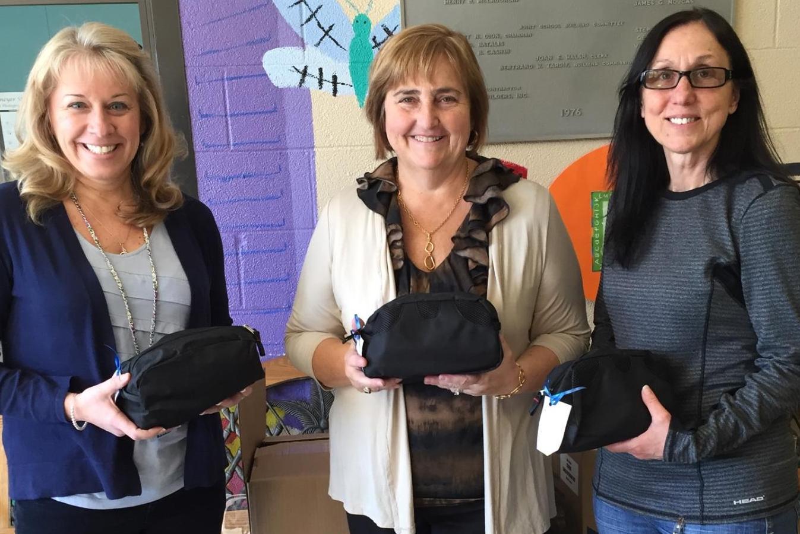
L to R: Lizabeth MacDonald, Principal, Kim Joseph
Want to get involved?





250 Brackett St, Portland, Me
Schedule for 2014
Volunteers Welcome!
Please contact Renee Dugas at
207-797-1635

Ronald McDonald Guest Chef
- May 11, 2015 – 45 Forest Ave
- June 8, 2015 – Life Members
- July 13, 2015 – 5 Davis Farm Rd
- August 10, 2015 – 45 Forest Ave
- September 14, 2015 – Life Members
- October 12, 2015 – 5 Davis Farm Rd
- November 9, 2015 – 45 Forest Ave
- December 14, 2015 – Life Members


If you would like to donate food to be used at the evening meals please contact Renee Dugas at 207 317 6798 or Christina Shea at 207 233 9133.


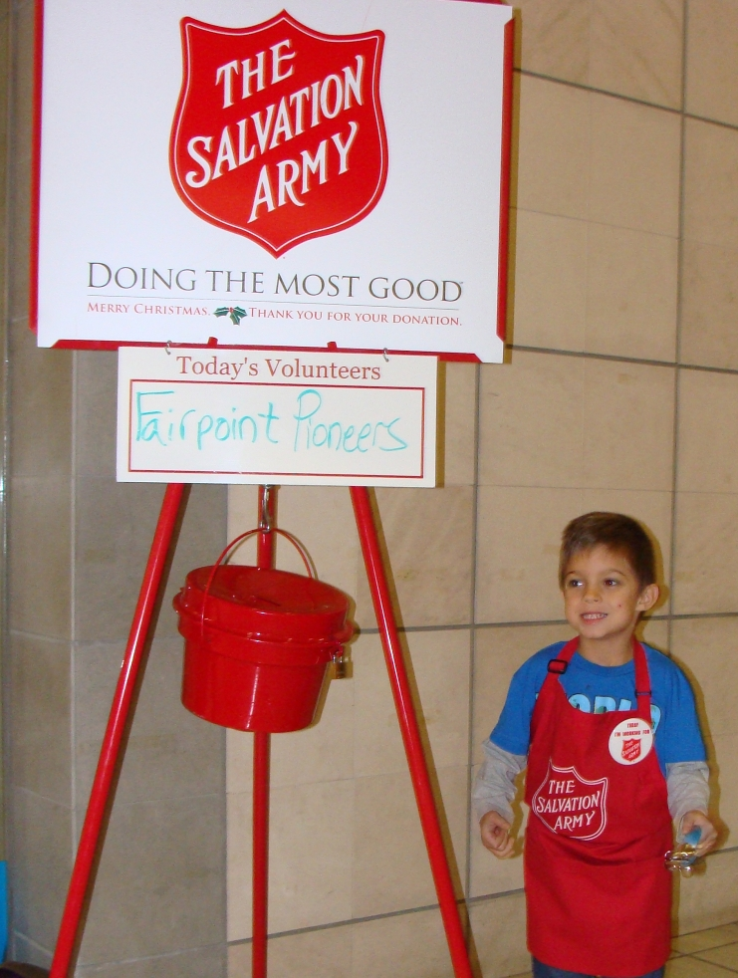
Contributions by Pioneers

This a poem by one of Pioneer's daughter....
I am a dancer
I wonder about people's feelings
I hear people laughing
I want world peace
I am a dancer
I pretend I am an awesome athlete
I feel I can do anything if I try
I touch my family's heart
I worry about people getting along
I cry when animals are hurt
I am a dancer
I understand that life isn't fair
I say that no one is perfect
I dream of going on a cruise
I try to be a nice person
I hope people like me
I am a dancer
By Whitney Valliant - age 8
"Happy Feet and Minds" aka
"Sock it to me"
The Keller Chapter is participating in the New Vision Pioneer Spring/Summer project. We will be providing books, socks and shoes to Pre K summer schools in the Chapter area. We will also volunteer to read to the students. If you are interested in helping please contact the Pioneer office at 603 656 8066.
*************************************
Thank to all of you who have made donations to the Keller Chapter....Without these donations we would not be able to provide the services we do. In 2013, there was over $13,000 that belong to the Keller Chapter that didn't have enough information to tie it to us. Please include your Chapter Name and Number - Jasper N Keller Chapter #33. We were able to recover the money.

Fun Trivia
- American car horns beep in the tone of F
- No piece of paper can be folded more than 7 times
- Donkeys kill more people annually than plane crashes
- 1 in 4 American has appeared on television
- You burn more calories sleeping than you do watching television
- Oak trees don not produce acorns until they are 50 years of age or older
- The first product to have a bar code was Wrigley’s gum
- The king of hearts is the only king without a mustache
- The 57 on the Heinz ketchup bottle represents the number of varieties of pickles the company once had
- The plastic things on the end of shoelaces are called “aglets”
- The first owner of the Marlboro Company died of lung cancer
- Betsy Ross is the only real person to ever have been on the head on a Pez dispenser
- Marilyn Monroe had 6 toes
- Walt Disney was afraid of mice
- Pearls melt in vinegar
- It takes 3,000 cows to supply the NFL with enough leather for a year’s supply of footballs

Volunteers are need to help at Special Olympics Summer Games!

Kim Paradis is looking for volunteers to help on June 4th to make sandwiches. If you can help please go to the Whittemore Center at UNH, Durham for 1:00 p m. She is also in needs of volunteers on the 5th and 6th to help in Olympic Town. If you can help than please come by 9:30 am. Kim can be reached at 603 664 7744.

American car horns beep in the tone of F.
American car horns beep in the tone of F.
No piece of paper can be folded more than 7 times.
Donkeys kill more people annually than plane crashes.
1 in every 4 Americans has appeared on television.
You burn more calories sleeping than you do watching television.
Oak trees do not produce acorns until they are fifty years of age or older.
The first product to have a bar code was Wrigley's gum.
The king of hearts is the only king without a mustache.
A Boeing 74 wingspan is longer than the Wright brother's first flight.
Venus is the only planet that rotates clockwise.
The first CD pressed in the US was Bruce Springsteen's "Born in the USA"
Apples, not caffeine, are more efficient at waking you up in the morning.
The 57 on the Heinz ketchup bottle represents the number of varieties of pickles the company once had.
The plastic things on the end of shoelaces are called "aglets."
Most dust particles in your house are made from dead skin.
The first owner of the Marlboro Company died of lung cancer.
Barbie's full name is Barbara Millicent Roberts.
Betsy Ross is the only real person to ever have been the head on a Piz dispenser.
Marilyn Monroe had six toes.
Walt Disney was afraid of mice.
The sound of EAT. walking was made by someone squishing her hands in jelly.
Debra Winger (went to school with her) was the voice of EAT.
Pearls melt in vinegar.
Bill Clinton has been in 3 porno films from the waste down.
It takes 3,000 cows to supply the NFL with enough leather for a year's supply of footballs.
The three most valuable brand names on earth: Marlboro, Coca Cola, and Budweiser, in that order.
Average life span of a major league baseball: seven pitches.
A duck's quack doesn't echo and no one knows why.
Richard Millhouse Nixon was the first US president whose name contains all the letters from the word "criminal." The second? William Jefferson Clinton.
American car horns beep in the tone of F.
No piece of paper can be folded more than 7 times.
Donkeys kill more people annually than plane crashes.
1 in every 4 Americans has appeared on television.
You burn more calories sleeping than you do watching television.
Oak trees do not produce acorns until they are fifty years of age or older.
The first product to have a bar code was Wrigley's gum.
The king of hearts is the only king without a mustache.
A Boeing 747s wingspan is longer than the Wright brother's first flight.
Venus is the only planet that rotates clockwise.
The first CD pressed in the US was Bruce Springsteen's "Born in the USA"
Apples, not caffeine, are more efficient at waking you up in the morning.
The 57 on the Heinz ketchup bottle represents the number of varieties of pickles the company once had.
The plastic things on the end of shoelaces are called "aglets."
Most dust particles in your house are made from dead skin.
The first owner of the Marlboro company died of lung cancer.
Barbie's full name is Barbara Millicent Roberts.
Betsy Ross is the only real person to ever have been the head on a Pez dispenser.
Marilyn Monroe had six toes.
Walt Disney was afraid of mice.
The sound of E.T. walking was made by someone squishing her hands in jelly.
Debra Winger (went to school with her) was the voice of E.T.
Pearls melt in vinegar.
Bill Clinton has been in 3 porno films from the waste down.
It takes 3,000 cows to supply the NFL with enough leather for a year's supply of footballs.
The three most valuable brand names on earth: Marlboro, Coca Cola, and Budweiser, in that order.
Average life span of a major league baseball: seven pitches.
A duck's quack doesn't echo and no one knows why.
Richard Millhouse Nixon was the first US president whose name contains all the letters from the word "criminal." The second? William Jefferson Clinton.

American car horns beep in the tone of F.
No piece of paper can be folded more than 7 times.
Donkeys kill more people annually than plane crashes.
1 in every 4 Americans has appeared on television.
You burn more calories sleeping than you do watching television.
Oak trees do not produce acorns until they are fifty years of age or older.
The first product to have a bar code was Wrigley's gum.
The king of hearts is the only king without a mustache.
A Boeing 747s wingspan is longer than the Wright brother's first flight.
Venus is the only planet that rotates clockwise.
The first CD pressed in the US was Bruce Springsteen's "Born in the USA"
Apples, not caffeine, are more efficient at waking you up in the morning.
The 57 on the Heinz ketchup bottle represents the number of varieties of pickles the company once had.
The plastic things on the end of shoelaces are called "aglets."
Most dust particles in your house are made from dead skin.
The first owner of the Marlboro company died of lung cancer.
Barbie's full name is Barbara Millicent Roberts.
Betsy Ross is the only real person to ever have been the head on a Pez dispenser.
Marilyn Monroe had six toes.
Walt Disney was afraid of mice.
The sound of E.T. walking was made by someone squishing her hands in jelly.
Debra Winger (went to school with her) was the voice of E.T.
Pearls melt in vinegar.
Bill Clinton has been in 3 porno films from the waste down.
It takes 3,000 cows to supply the NFL with enough leather for a year's supply of footballs.
The three most valuable brand names on earth: Marlboro, Coca Cola, and Budweiser, in that order.
Average life span of a major league baseball: seven pitches.
A duck's quack doesn't echo and no one knows why.
Richard Millhouse Nixon was the first US president whose name contains all the letters from the word "criminal." The second? William Jefferson Clinton.

a

e

