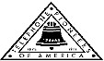 Jasper N. Keller Chapter #33
“Answering the call of those in need”
ISSUE 5, VOL. 9 September 2015

From the President’s desk…
Every day as I drive to the Pioneer Office at 770 Elm St., I see many sights. Far too many homeless men and women, and today I notice a homeless mother with three children. So, sad! We need to help these people; winter is knocking on the door and what will become of them? However, the best I have seen was a cat sitting on a ledge in the sun taking a bath, the window was open to the apartment. Take a minute and notice your surroundings.
One of the most frustrating things is when you are stopped at a red light, at a 4 way stop and there is not a vehicle in site. Really, if only I wanted to turn right. Then there are the people who really really need to pay extra and get a signal light or when someone wants to cut across the line of traffic and the person in front waves them on….who is responsible if they are t-boned by another car?
I can’t believe that the leaves are starting to turn color and falling to the ground. The swamp maples are a beautiful shade of red this year.
It’s that time of the year when the Councils, Life Member Clubs and Chapter start to plan for 2016. It’s budget time! I will be attending a Face to Face meeting in October and sharing with the Presidents and Vice Presidents the new Budget process. It’s really not hard, and the Budget is not cast in stone. However, many make it difficult, or have a mental block when anyone mentions Budgets!
Remember school in back! Watch out for the kiddos.

How well do you know your place settings!

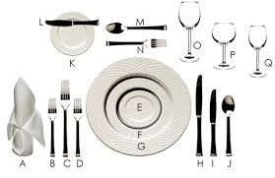

And what does this tell the wait staff?

- B. C.

D. E.
And than there are manners!

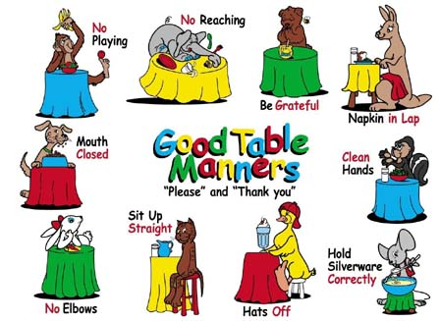

Monthly Meeting Dates and Times for the Chapter, Council & Life Member Clubs Cont.

Southern NH LMC: Will have the following: Luncheons schedule for 2015 are as follows 9/17 & 12/10 Please note your calendars.... They will be held at the The Yard Restaurant in Manchester, NH. If you are not on the Luncheon list or know someone who should be please, contact Bill Macy at 603 890 1572.

Northern NH LMC: Dates for 2015 luncheons are as follows: Thursday, October 8th at 11:30 am at Town and Country Motor Inn, Shelburne, NH. Please contact Rachel French at rfrench89@gmail.com for more information.
2015 NNH LMC Officers:
President - Clayton “Bushy” Bushman
Vice President - Peggy Winton
Treasurer - Rachel French
Secretary – Colleen Drouin
Caller Chairperson – Rachel French
Fellowship - Pat Pike

Vermont
Vermont LMC: September 30th at 11:00 am in Montpelier at the Capital Plaza on 100 State St. We will be in the Ethan Allen Room. VT Chicken (with ham & cheese), potato, vegetable and raspberry-lemon cake for dessert. The cost is $15.00; checks need to reach Kay by September 1st. Please contact Kay Hopkins for more information about 2015 up coming luncheons at 802-684-2124 (Res), 802-535-4702 (cell).

Please help us keep in touch

If you know of anyone who is having a milestone birthday or passes away please let the Pioneer office know (603 656 8066).

Monthly Meeting Dates and Times for the Chapter, Council & Life Member Clubs

Maine
Portland Council: Meets the 2nd Tuesday of each month from 9 am to 11 am at 1 Davis Farm Rd., Portland, Me. For details email: mainepioneers@fairpoint.com.

Bangor Life Member Club:
For more information please contact Cindy Black at eastport4the4th@msn.com.
Kennebec Life Member Club: Meets the last Wednesday of the month at 11:00 am alternately in Waterville or Augusta. Please contact Kathy Camann at 207-872-2355 or dkcamann@myfairpoint.net for locations or more information.
Portland Life Member Club: Meets the 2nd Thursday of each month at 11:30 am at Thatcher’s Restaurant, Foden Rd. S Portland, Me…Any retirees in the Portland area please come and join us.
New Hampshire
New Hampshire Council: Meets the 3rd Thursday of each month from 2 p.m. to 5 p.m. at 875 Holt Ave., Manchester, NH contact Pascale Coates for more details at 603 479 4718

Dover/Portsmouth LMC: Meets the 2nd Tuesday of each month starting at 11:30 am at Rogers Pizza at 869 Central Ave, Dover, NH. The fall luncheon will be October 13th at 11:30 at Granite Steak and Grill. Contact Kim Paradis for more details at 603 664 7744.

A. Napkin, B. Fish fork, C. Dinner fork, D. Salad fork, E. Salad plate, F. Dinner plate, G. Service plate, H. Dinner knife, I. Fish knife, J. Soup or fruit spoon, K. Butter plate L. Butter knife, M. Dessert spoon, N. Cake fork, O. Water glass, P. Red wine glass, Q. White wine glass – A. Pause, B. Ready for second plate, C. Excellent, D. Finished, E. Do not like

Keller Chapter Talking Book Program for NH
Jim Dimick, spokesperson for the Talking Book Program in Concord, NH recently explained to the NNH LMC what it is all about. This is a state and federally run program maintained by volunteers. They meet in Concord, NH on Monday mornings from 8:00 am to 12:00 noon taking July and August off. They no longer support the old tape player method, there is the new electronic machine which is easier to maintain. This very successful program started in 1985 and has continued for 30 years. Current members are Barney Colgan, Cecile Soucy and Jim Dimick. Jim is looking for 2 volunteers. If you are interested in volunteering please contact Jim at ejdimick8@gmail.com.



VT LMC 10 Week Club
The VT LMC is looking for people to run the 10 Week Club next year. If you are interested please contact Kay Hopkins at 802 684 2124 or Linda Roberts at 802 229 6132.
Week 1 winners: Week 3 Winners:
Janet Bossie Jameson Perrault
Gary Morse Joan Kelton
Stanley Titus Dakota Johnson
Euclid Renaud Sue Yantiss
Alex Weinhagen Wanda Webster
Week 2 winners: Week 3 Winners:
Tom Southworth Jean Henshaw
Connor Brown Timothy Brewer
Carolyn Palmer June Nadeau
Alan Stahl Bob Fowler
Virginia Hempstead Greg Owens

You can never have too many friends. Please ‘like’ us to keep up with what’s going on in the Jasper N. Keller Chapter #33. Here is the link to use for Facebook

https://www.facebook.com/pages/Pioneers-FairPoint-Jasper-N-Keller-Chapter-33/177159619001637?ref=hl

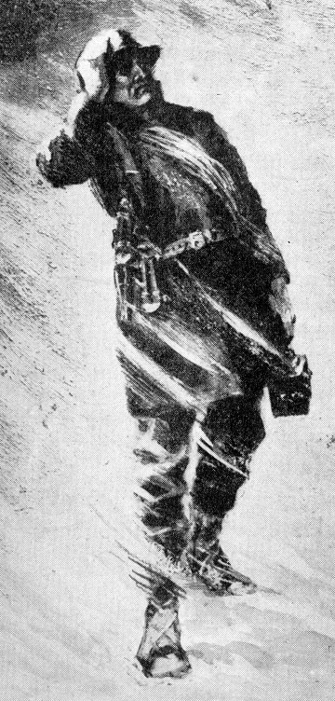

Want to get involved?



250 Brackett St, Portland, Me
Schedule for 2014
Volunteers Welcome!
Please contact Renee Dugas at
207-797-1635
Ronald McDonald Guest Chef
- September 14, 2015 – Life Members
- October 12, 2015 – 5 Davis Farm Rd
- November 9, 2015 – 45 Forest Ave
- December 14, 2015 – Life Members

2016 Dates will be coming out soon!

If you would like to donate food to be used at the evening meals please contact Renee Dugas at 207 317 6798 or Christina Shea at 207 233 9133.

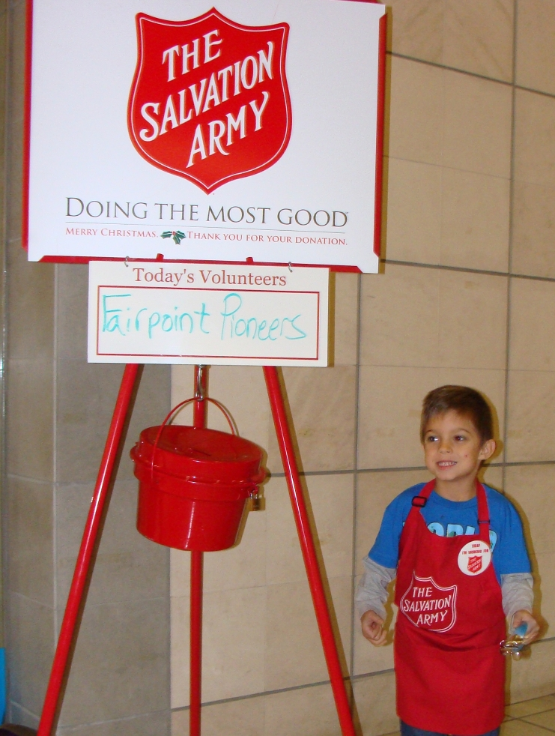
Portland Council


What: Benefit Auction for Camp Susan Curtis
When: Thursday, Oct. 22, 2015
Where: Westbrook Campus of Husson University
Why: Volunteers are needed for the following:
• Set-up (3-5 p.m.)
• Check-in (5–6 p.m.)
• Silent/live auction monitors (6–8 p.m.) • Check-out/item runners (8-8:30 p.m. approx.)
More Information: Camp Susan Curtis provides tuition-free outdoor residential learning and recreational experiences exclusively for economically disadvantaged Maine boys and girls, ages 8 to 17. Children return year-after-year, advancing through Camp Susan Curtis programs and developing habits and skills that help create a foundation for lifelong achievement. To learn more or to sign-up, email info@susancurtisfoundation.org, call 207-774-1552, or visit www.susancurtisfoundation.org.
Dish It Up!
Please help the FairPoint Pioneers with a donation to provide healthy meals to families through the Pioneers Dish it Up program. We are kicking off the program on October 16, 2015 and it will run through November 7, 2015. Please help so that children and adults don’t go to bed hungry at night. Thank you. Collection boxes will be at Company locations.

Place Settings: A.Napkin, B. Fish Fork, C. Dinner Fork, D. Salad Fork, E. Soup Bowl, F. Salad Plate, G. Dinner Plate, H. Dinner Knife, I. Fish Knife, J. Tea Spoon, K. Bread Dish, L. Butter Knife, M. Dessert Spoon, N. Cake Fork, O. Water Glass, P. Red Wine Glass, Q. White Wine Glass
Fork & Knife placement: A. Pause, B. Ready for a Second Plate, C. Excellent, D. Finished, E. Do Not Like

New Hampshire Council
The day was warm and the crowds were huge, as the NH Clown Troupe made its way down the parade route for the Londonderry Old Home Days Parade.
We were lucky to have 3 go carts and several clowns in various shapes and sizes. Along with the “Bubba” truck pulling a trailer with the Pioneer sponsored U8 State Champions softball team.
The 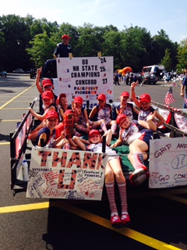
Bill Clinton has waste down. 
The highlight of the parade was the ice cream afterwards at Mac’s apple. That’s it until next year. Some of the girls move up to other teams, but you can bet the Pioneers will once again be there rooting them on.

Cola, and Budweiser, in that order
Average life span of a major league baseball: seven pitches.
A duck's quack doesn't echo and no one knows why.
Richard Millhouse Nixon was the first US president whose name contains all the letters from the word "criminal second? William Jefferson Clinton.
American car horns beep in
Donkeys kill more people annually than plane crashes.
1 in every 4 Americans has appeared on television.
You burn more calories sleeping than you do watching television.
Oak trees do not produce acorns until they are fifty years of age or older.
The first product to have a bar code was Wrigley's gum.
The king of hearts is the only king without a mustache.
A Boeing 747s wingspan is longer than the Wright brother's first flight.
Venus is the only planet that rotates clockwise.
The first CD pressed in the US was Bruce Springsteen's "Born in the USA"
Apples, not caffeine, are more efficient at waking you up in the morning.
The 57 on the Heinz ketchup bottle represents the number of varieties of pickles the company once had.
The plastic things on the end of shoelaces are called "aglets."
Most dust particles in your house are made from dead skin.
The first owner of the Marlboro com died of lung cancer.
Barbie's full name is Barbara Millicent Roberts.
Betsy Ross is the only real person to ever have been the head on a Pez dispenser.
Marilyn Monroe had six toes.
Walt Disney was afraid of mice.
The sound of E.T. walking was made by someone squishing her hands in jelly.
Debra Winger (went to school with her) was the voice of E.T.
Pearls melt in vinegar.
Bill Clinton has been in 3 porno films from the waste down.
It takes 3,000 cows to supply the NFL with enough leather for a year's supply of footballs.
The three most valuable brand names on earth: Marlboro, Coca Cola, and Budweiser, in that order.
Average life span of a major league baseball: seven pitches.
A duck's quack doesn't echo and no one knows why.
Richard Millhouse Nixon was the first US president whose name contains all the letters from the word "criminal." William Jefferson Clinton.

American car horns beep in the tone of F.
No piece of paper can be folded more than 7 times.
Donkeys kill more people annually than plane crashes.
1 in every 4 Americans has appeared on television.
You burn more calories sleeping than you do watching television.
Oak trees do not produce acorns until they are fifty years of age or older.
The first product to have a bar code was Wrigley's gum.
The king of hearts is the only king without a mustache.
A Boeing 747s wingspan is longer than the Wright brother's first flight.
Venus is the only planet that rotates clockwise.
The first CD pressed in the US was Bruce Springsteen's "Born in the USA"
Apples, not caffeine, are more efficient at waking you up in the morning.
The 57 on the Heinz ketchup bottle represents the number of varieties of pickles the company once had.
The plastic things on the end of shoelaces are called "aglets."
Most dust particles in your house are made from dead skin.
Barbie's full name is Barbara Millicent Roberts.
Betsy Ross is the only real person to ever have been the head on a Pez dispenser.
Marilyn Monroe had six toes.
Walt Disney was afraid of mice.
The sound of E.T. walking was made by someone squishing her hands in jelly.
Debra Winger (went to school with her) was the voice of E.T.
Pearls melt in vinegar.
Bill Clinton has been in 3 porno films from the waste down.
It takes 3,000 cows to supply the NFL with enough leather for a year's supply of footballs.
The three most valuable brand names on earth: Marlboro, Coca Cola, and Budweiser, in that order.
Average life span of a major league baseball: seven pitches.
A duck's quack doesn't echo and no one knows why.
Richard Millhouse Nixon was the first US president whose name contains all the letters from the word "criminal." William Jefferson Clinton.

7

