 Jasper N. Keller Chapter #33
“Answering the call of those in need”
ISSUE 2, VOL. 4 February 2014

Valentine’s Day!
Valentine's Day, red roses, candy in heart- shaped boxes, and saccharine sweet valentine's cards come to mind. Do we really need any of this? A little peck on the check and a hug goes a long way with me. Why not purchase something “they” can use?


Why not support the Pioneers and order from RADA?
On-line Ordering Instructions:
Go to this website: www.helpourfundraiser.com
Enter the following: Internet Ordering number: 504282/Password:
pioneer (small letters)
Click on BROWSE and browse the Catalog
Place your order.
OR
What about some flower seeds or bulbs for “their” garden
Flower Power
http://www.flowerpowerfundraising.com/campaign?campaign_id=17573&user_campaign_id=406800



Calendar of upcoming Events – Mark your calendars
Portland Council

New Hampshire Council

From the President’s desk…
As we say good bye to January, I can say I will not miss that month at all. According to the weather man, if you can believe him, this has been the coldest winter in years. I can agree with that, my furnace seems to run constantly.
So far, 2014 hasn’t been that good for Richard, he had cataract surgery and that didn’t go well, pressure is still high and he has inflammation in the eye. Than, he took a “header” off the loading dock at Agway when he was getting deer food. Tore his ACL and fractured the bone behind his kneecap. He is in a knee brace and ankle brace, not to sure what he did to his ankle. Plus everything else that is wrong, he is a walking “train wreck”. I must be in the wrong profession; I would make a great nurse, Not!
My daughter has hurt her back and has had to have 2 shorts in it…Luckily I have been able to stay healthy this year! And up right!
I have been busy making camping reservations for this year. We are going to Skowhegan for two weeks this year. Of course, I didn’t check the calendar before I made the reservations, it the same time that the “Skowhegan Fair” is in town. Good Grief!! Been there done that. Happy Valentines Day to one and all.


Monthly Meeting Dates and Times for the Chapter, Council & Life Member Clubs Cont.

Southern NH LMC: Will have the following: Luncheons schedule for 2014: Will be announced shortly. They will be held at the The Yard Restaurant in Manchester, NH. If you are not on the Luncheon list or know someone who should be please contact Bill Macy at 603 890 1572.

Northern NH LMC: Dates for 2014 luncheons will be coming out soon. Please contact Rachel French at rfrench89@gmail.com for more information.

Vermont
Vermont LMC: Dates for the 2014 luncheons will be coming out soon. Please contact Kay Hopkins for more information at 802-684-2124 (house), 802-535-4702 (cell).

You can never have too many friends. Please ‘like’ us to keep up with what’s going on in the Jasper N. Keller Chapter #33. Here is the link to use for Facebook

https://www.facebook.com/pages/Pioneers-FairPoint-Jasper-N-Keller-Chapter-33/177159619001637?ref=hl



Monthly Meeting Dates and Times for the Chapter, Council & Life Member Clubs

Maine
Portland Council: Meets the 2nd Tuesday of each month from 9 am to 11 am at 1 Davis Farm Rd., Portland, Me. Contact Christina Shea for more details at: mainepioneers@fairpoint.com.

Bangor Life Member Club:
There is going to be an informational meeting on 1/22/14 at Pat’s Pizza in Ellsworth, Me at noon. The Bangor and Hancock LMC’s are coming forces to be better and stronger. For more information please contact Cindy Black at eastport4the4th@msn.com.
Kennebec Life Member Club: Meets the last Wednesday of the month at 11:00 am alternately in Waterville or Augusta. Please contact Kathy Camann at 207-872-2355 or dkcamann@myfairpoint.net for locations or more information.
Portland Life Member Club: Meets the 2nd Thursday of each month at 11:30 am at Thatcher’s Restaurant, Foden Rd. S Portland, Me…Any retirees in the Portland area please come and join us.
New Hampshire

New Hampshire Council: Meets the 3rd Tuesday of each month from 3 p.m. to 6 p.m. at 875 Holt Ave., Manchester, NH contact Pascale Coates for more details at 603 479 4718

Dover/Portsmouth LMC: Meets the 2nd Tuesday of each month starting at 11:30 am at Rogers Pizza at 869 Central Ave, Dover, NH. Contact Kim Paradis for more details at 603 664 7744

Pioneers in the news!

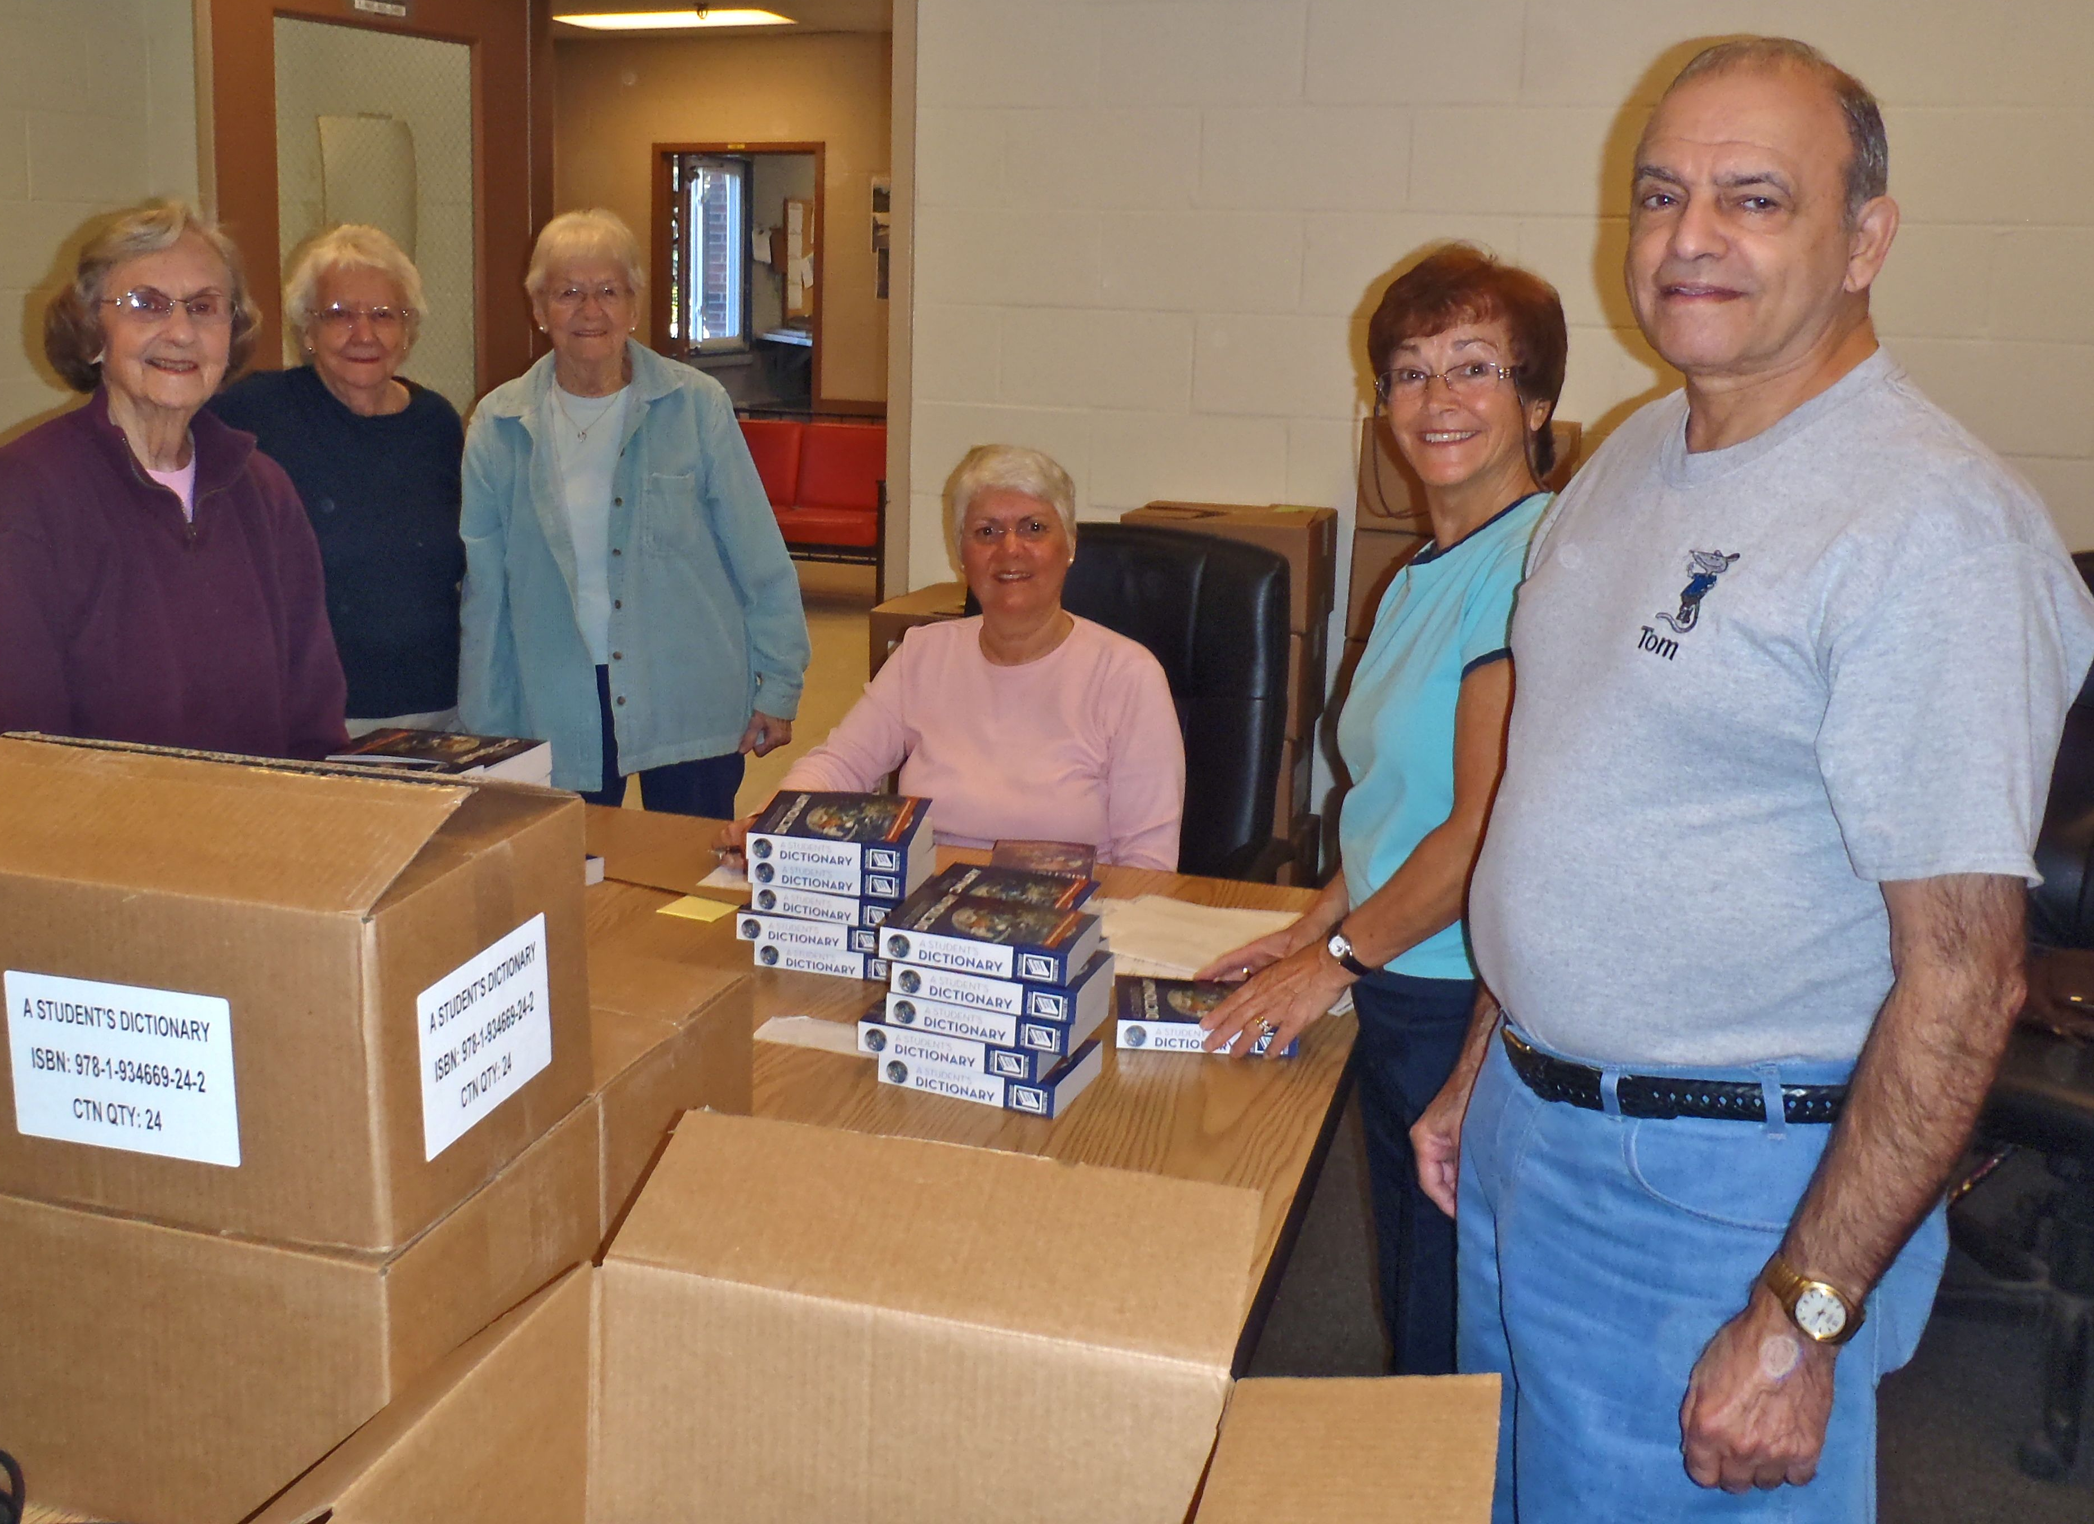
L to R: Barbara Tracy, Priscilla Maheu,
Marilyn Lohnes, Terry Leclerc, Louise Proulx and Tom Corey.
Kennebec Life Member Club putting labels on dictionaries. The dictionaries were given to school in the Waterville, ME area.

From the Chicago Telephone Company October 28, 1911
Rules for Trouble men
“Put up a “good front.” It is not necessary to advertise any tailor shop, neither is it necessary to go about your work looking like a coal heaver. Overalls can look as respectable as anything else, but they must at least show that they are on speaking terms with the laundryman; and shoes must have a bowing acquaintance with the bootblack.” Amazing, and people were sent home if they didn’t comply!
Punxsutawney Phil saw his shadow!
Six more weeks of winter…I with Phil!



Want to get involved?



Ronald McDonald House
250 Brackett St, Portland, Me
Schedule for 2013
Volunteers Welcome!
Please contact Christina Shea at
603 227 3557

2014 Dates & who’s Responsible
- February 10, 2014 – 5 Davis Farm Rd
- March 10, 2014 – Life Members
- April 14, 2014 – 5 Davis Farm Rd
- May 12, 2014 – 45 Forest Ave
- June 9, 2014 – Life Members
- July 14, 2014 – 5 Davis Farm Rd
- August 11, 2014 – 45 Forest Ave
- September 8, 2014 – Life Members
- October 13, 2014 – 5 Davis Farm Rd
- November 10, 2014 – 45 Forest Ave
- December 8, 2014 – Life Members

Other Volunteer Activities
Maine:

New Hampshire:
Special Olympics NH Winter Games March 2nd – March 4th, 2014 to volunteer contact email: ehackett@metrocast.net
Home: 603-267-8888, Cell # 603-716-3715




Clip Coupons - Help Military Families - Update
We have just recently learned that overseas military bases are in need of coupons. They can use these in the PEX’s and NEX’s. They will accept expired grocery coupons up to two months from their expiration date as well as non-expired coupons. Will you help? If you would like to donate coupons please send them to Julie Scala, 5 Davis Farm Rd., Portland, ME 04103

January 2014
Category | Number of coupons | Value of coupons
Non-Food | 7400 | $15,787.77
Food | 5280 | $ 5,290.15
Baby | 252 | $ 367.50
Pet | 428 | $ 785.16
Totals | 13360 | $22,230.58

Packets sent: | 3

Interesting Item….



A friend of mine is a wood carver and he was carving one of these one time we were camping, I realized it was an eagle, but not sure what it was for. He explained that the carving club he belongs to carves the head than they are attached to the walking stick. The Eagle Cane project was found in 2004. His carving club has chosen to give the Eagle head walking sticks to local veterans who have served in wartime since World War II. Each of the veterans receiving a cane has served active duty during at least one of our war times.
The practice of honoring service men and women through a cane presentation ceremony dates back to the Civil War as a sign of respect and honor for wounded troops. The bald eagle carved onto the cane is emblematic of service, as a symbol of the United States. Additionally, Native Americans believed that warriors wounded on the battlefield returned as eagles. The eagle cane presentation is means to honor veterans for personal sacrifice.


