 Jasper N. Keller Chapter #33
“Answering the call of those in need”
ISSUE 3, VOL. 4 March 2014

Calling knitters or crocheter!
We have been contacted by the Center for Grieving Children in Portland, ME; they a retreat in November and have asked us to donate 100 lap robes for the children. They can be store bought, fleece or knitted or crocheted. If you would like to help please contact the Pioneer office at 603 645 2666 or email marypl@myfairpoint.net .

Easter and Mother’s Day
Are right around the corner!

Why not support the Pioneers and order from RADA?
On-line Ordering Instructions:
Go to this website: www.helpourfundraiser.com
Enter the following: Internet Ordering number: 504282/Password:
pioneer (small letters)
Click on BROWSE and browse the Catalog
Place your order.
OR
What about some flower seeds or bulbs for “their” garden
Flower Power
http://www.flowerpowerfundraising.com/campaign?campaign_id=17573&user_campaign_id=406800


Calendar of upcoming Events – Mark your calendars
Portland Council

New Hampshire Council

From the President’s desk…
“In like a Lion and out like a Lamb”! I am so done with winter. I can’t wait for the Lamb to show up…I love Lamb; my daughter cooks a mean leg of Lamb. Ooops, off the subject…Speaking of getting off the subject, I was at a Chapter meeting a couple of months ago, it was the year end meeting and there was a lot to cover, I did have an agenda, however, one statement lead to a question about something else, and we were off….as the President of the Portland Council says “hang onto your hat, were on a roller coaster ride”. I hate not to address someone’s question when it comes up…one they might forget it and two it was pertinent to them at the time.
Once again the Pioneers are so grateful to Sol mate socks of Vermont. Because of them there are hundreds of warm feet in the Keller Chapters area. I have to drive by the Manchester Soup Kitchen on my way home every night…I can’t believe how many people are in line for a meal. The United States helps other countries, what about our folks. It is a shame that people in the United States have to go homeless and hungry.
I have been collecting peanut butter her at 770 Elm St.; I am shooting for 50 jars. Not unrealistic I don’t think. The Food Bank had called to see if we would collect peanut butter, no jelly just peanut butter. We have until the 14th...But we will make it.

Monthly Meeting Dates and Times for the Chapter, Council & Life Member Clubs Cont.

Southern NH LMC: Will have the following: Luncheons schedule for 2014: May 22nd, Sept. 25th. and December 11 (turkey dinner). They will be held at the The Yard Restaurant in Manchester, NH. If you are not on the Luncheon list or know someone who should be please contact Bill Macy at 603 890 1572.

Northern NH LMC: Dates for 2014 luncheons will be coming out soon. Please contact Rachel French at rfrench89@gmail.com for more information.

Vermont
Vermont LMC: Dates for the 2014 luncheons will be coming out soon. Please contact Kay Hopkins for more information at 802-684-2124 (house), 802-535-4702 (cell).

You can never have too many friends. Please ‘like’ us to keep up with what’s going on in the Jasper N. Keller Chapter #33. Here is the link to use for Facebook

https://www.facebook.com/pages/Pioneers-FairPoint-Jasper-N-Keller-Chapter-33/177159619001637?ref=hl



Monthly Meeting Dates and Times for the Chapter, Council & Life Member Clubs

Maine
Portland Council: Meets the 2nd Tuesday of each month from 9 am to 11 am at 1 Davis Farm Rd., Portland, Me. Contact Christina Shea for more details at: mainepioneers@fairpoint.com.

Bangor Life Member Club:
For more information please contact Cindy Black at eastport4the4th@msn.com.

Kennebec Life Member Club: Meets the last Wednesday of the month at 11:00 am alternately in Waterville or Augusta. Please contact Kathy Camann at 207-872-2355 or dkcamann@myfairpoint.net for locations or more information.
Portland Life Member Club: Meets the 2nd Thursday of each month at 11:30 am at Thatcher’s Restaurant, Foden Rd. S Portland, Me…Any retirees in the Portland area please come and join us.

New Hampshire

New Hampshire Council: Meets the 3rd Tuesday of each month from 3 p.m. to 6 p.m. at 875 Holt Ave., Manchester, NH contact Pascale Coates for more details at 603 479 4718

Dover/Portsmouth LMC: Meets the 2nd Tuesday of each month starting at 11:30 am at Rogers Pizza at 869 Central Ave, Dover, NH. Contact Kim Paradis for more details at 603 664 7744

Direct Marketing appeal-

I would personally like to thank all of you that support the Jasper N. Keller Chapter though the “Direct Marketing” campaigns. The money that the Keller Chapter receives gives us that extra shot in the arm to be able to additional projects in our communities. I know that the dollar doesn’t go as far as it used to, but with your continued support and the support of others we can make our communities a better place to live for the less fortunate. By supporting the Pioneers you ensure our legacy of giving back to our communities through volunteerism continues for generations to come. Did you know that your gift of $25.00 will help supply food to people facing hunger, $50.00 will help clean-up a local park or playground and that $100.00 will help provide school supplies to children? Any charitable contributions to the Pioneers are tax deductible to the extent allowed by law in the U.S. If you prefer to make a donation directly to the Keller Chapter, you can send it to us at 770 Elm St., Manchester, NH 03101. Thank you for your continued support.

Camp Susan Curtis –
It's been 40 years since then - Gov. Ken Curtis and his wife, Pauline, lost their 11-year-old daughter, Susan, to cystic fibrosis. Not long afterward, several close friends, including a number of the governor's top fundraisers, approached Curtis and proposed starting a nonprofit foundation to receive the donations many wanted to make in Susan's memory.
The Portland Council will be taking on working to provide items on the wish list for the camp. Some of the items needed are for general program & operations such as: cleaning products, batteries – all sizes, zip lock bag – all sizes, sharpie pens – all sizes & colors and clip on reading lamps; just to name a few. Please contact the Portland council at mainepioneers@fairpoint.com to help.

Want to get involved?



Ronald McDonald House
250 Brackett St, Portland, Me
Schedule for 2013
Volunteers Welcome!
Please contact Christina Shea at
603 227 3557

2014 Dates & who’s Responsible
- March 10, 2014 – Life Members
- April 14, 2014 – 5 Davis Farm Rd
- May 12, 2014 – 45 Forest Ave
- June 9, 2014 – Life Members
- July 14, 2014 – 5 Davis Farm Rd
- August 11, 2014 – 45 Forest Ave
- September 8, 2014 – Life Members
- October 13, 2014 – 5 Davis Farm Rd
- November 10, 2014 – 45 Forest Ave
- December 8, 2014 – Life Members

Other Volunteer Activities

New Hampshire:

2014 Manchester St. Patrick’s Day Parade
Sunday, March 30th, 2014 starts at noon. Come and have fun with the clowns and go carts, for more information contact Maureen Fogg at mfogg@fairpoint.com

New Hampshire Public Television is holding their Winter Auction on April 25 thru May 5th in Durham, NH. Volunteers are needed to work the phone banks. Please contact Maureen Fogg at mfogg@fairpoint.com


Troupons up Date
Will you help? If you would like to donate coupons please send them to Julie Scala, 5 Davis Farm Rd., Portland, ME 04103
February 2014
Category | Number of coupons | Value of coupons
Non-Food | 37491 | $71,545.50
Food | 23793 | $ 23,637.00
Baby | 1117 | $ 1,883.99
Pet | 2377 | $ 3,657.98
Totals | 64778 | $100,724.47

Packets sent: | 42


Pioneers in the news!
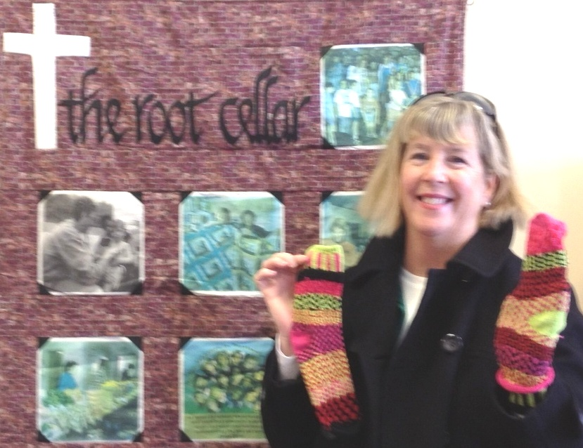
Betsi Dupont dropped of many pairs of warm donated socks to The Root Cellar in Portland, ME.

Olympics in Saco, Maine

Young School in Saco has about 300 students and serves K-2nd grade. The students recently learned about Sochi Russia and the Olympics. Each of the 19 classrooms was assigned a Country. They learned about their Country and the Olympians from that Country. They then “represented” their Country at the Young School Winter Olympics. They had an opening Ceremony, complete with the Parade of Countries before going onto Olympic Events. Because of the cold weather (subzero that day) all events were held inside. They included “(Styrofoam) snowball toss”, Scooter races, Snow sculpture (using modeling clay); floor hockey, and big foot races among others. The kids enjoyed the Olympics until lunch time. They even made “bagel bears for snack time (because the Sochi Olympic mascot was a bear.)
The Olympic torch was carried into the opening ceremony by Principal Dr. Peter Harrison. After the Olympics, Christina Shea, President of the Portland Council brought the torch around to classrooms so the students could have an up close look at the torch and hear a bit about the 84 Summer Olympics in LA. The Olympic touch was carried by Bob Payne (retired from New England Telephone) in the 1984 Torch Rely in Massachusetts and Bob was a member of the torch support team in the Northwest.

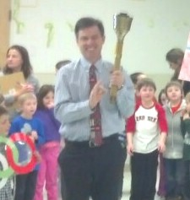
Principal Dr. Harrison Christina & Connor Shea

