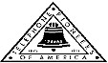 Jasper N. Keller Chapter #33
“Answering the call of those in need”
ISSUE 3, VOL. 11 November 2014

From the President’s desk…
OK, let's try this one more time! No pun intended...Now you can turn your clocks back this weekend.....well, at least according to the television, if you can believe them! Sorry about the confusion from last month.
There are so many things running through my thoughts this month...it will be hard to express them all. First, I attended a Face to Face meeting with the other presidents in our group. It was interesting to see that we all share the same problems, in "Answering the call of those in need", not enough volunteers, not enough time and not enough money.
Then there is the issue of the Work Stoppage by the Union employees of FairPoint. As Pioneers, we can't and don't take any "sides" not sure that is the correct word, but you understand what I am saying. All we can do is keep everyone in our thoughts and prayers through this difficult time. Of course, we can't conduct any Pioneer activities during the Work Stoppage...which is very unfortunate for our communities and organizations that we support. What with the cold weather and holidays right around the corner.
I would like to thank everyone who supported the Pioneers in the recent BJ's fund raiser. We did very well, thanks again.

November Trivia Quiz!

- What is the birthstone for November?

- JFK was assassinated in November of what year?

- Lincoln gave his Gettysburg address in November of what year?

- On the ancient Roman calendar What month is November?

- What happens on the first Tuesday following the first Monday in November?

- Who was born on November 2, 1734?

- How many days are in November during a leap year?

- What astrological signs does November begin and end with?

- The word November comes from the Latin word "novem" which means?

- What holiday is celebrated on November 1st?

- What day was Ned Kelly Hanged?


Monthly Meeting Dates and Times for the Chapter, Council & Life Member Clubs Cont.

Southern NH LMC: Will have the following: Luncheons schedule for 2014: December 11th (turkey dinner). They will be held at the The Yard Restaurant in Manchester, NH. If you are not on the Luncheon list or know someone who should be please contact Bill Macy at 603 890 1572.

Northern NH LMC: Dates for 2014 luncheons will be coming out soon. Please contact Rachel French at rfrench89@gmail.com for more information.

Vermont
Vermont LMC: Please contact Kay Hopkins for more information about 2015 up coming luncheons at 802-684-2124 (house), 802-535-4702 (cell).

You can never have too many friends. Please ‘like’ us to keep up with what’s going on in the Jasper N. Keller Chapter #33. Here is the link to use for Facebook

https://www.facebook.com/pages/Pioneers-FairPoint-Jasper-N-Keller-Chapter-33/177159619001637?ref=hl

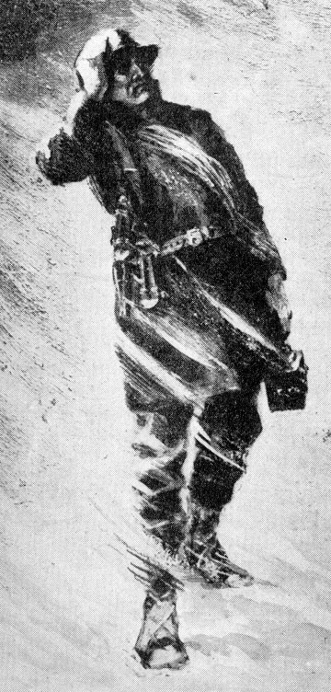

Monthly Meeting Dates and Times for the Chapter, Council & Life Member Clubs

Maine
Portland Council: Meets the 2nd Tuesday of each month from 9 am to 11 am at 1 Davis Farm Rd., Portland, Me. Contact Christina Shea for more details at: mainepioneers@fairpoint.com.

Bangor Life Member Club:
For more information please contact Cindy Black at eastport4the4th@msn.com.

Kennebec Life Member Club: Meets the last Wednesday of the month at 11:00 am alternately in Waterville or Augusta. Please contact Kathy Camann at 207-872-2355 or dkcamann@myfairpoint.net for locations or more information.
Portland Life Member Club: Meets the 2nd Thursday of each month at 11:30 am at Thatcher’s Restaurant, Foden Rd. S Portland, Me…Any retirees in the Portland area please come and join us.

New Hampshire

New Hampshire Council: Meets the 3rd Thursday of each month from 3 p.m. to 6 p.m. at 875 Holt Ave., Manchester, NH contact Pascale Coates for more details at 603 479 4718

Dover/Portsmouth LMC: Meets the 2nd Tuesday of each month starting at 11:30 am at Rogers Pizza at 869 Central Ave, Dover, NH. Contact Kim Paradis for more details at 603 664 7744

What’s going on in the Council’s?

There will be no planned activities during the Work Stoppage

Annual Fall Northwood St Park clean Up day

Before - Southern NH Life Club President Bill Macy clearing brush.

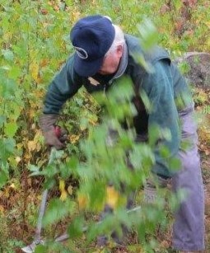

After - NH Council President Maureen Fogg. Who would have thought that was even there.



Thanks everyone for our hard work and dedication

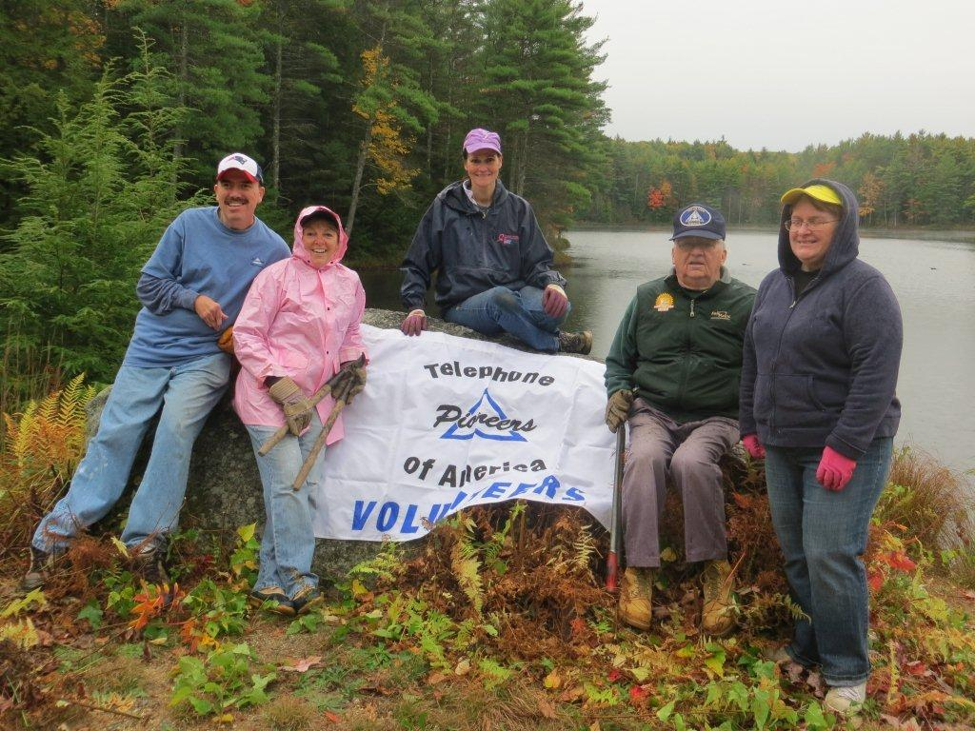

Congratulations to the Dover/Portsmouth LMC

Great Bay Services
2014 Annual Awards Ceremony
Great Bay Services annual awards ceremony to honor and thank many who have made a significant contribution to our continued success.

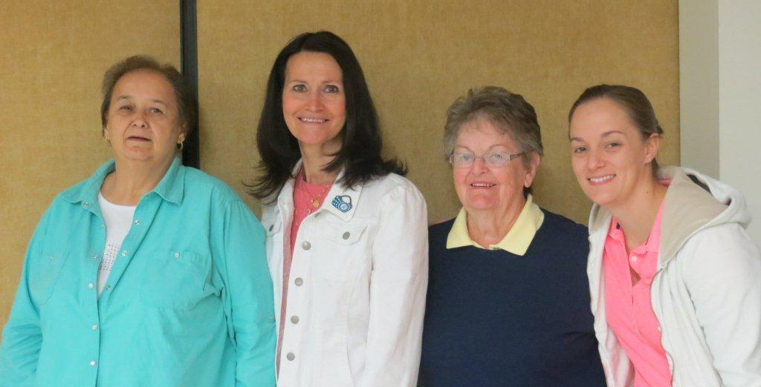
L to R: Betty Houle, Kim Paradis (President LMC), Betty Rowe & Betty Rowe’s grand daughter

Want to get involved?





250 Brackett St, Portland, Me
Schedule for 2014
Volunteers Welcome!
Please contact Renee Dugas at
207-797-1635
Ronald McDonald Guest Chef
2014 & 2015
- November 10, 2014 – 45 Forest Ave
- December 8, 2014 – Life Members
- January 12, 2015 – 5 Davis Farm Rd
- February 9, 2015 – 45 Forest Ave
- March 9, 2015 – Life Members
- April 13, 2015 – 5 Davis Farm Rd
- May 11, 2015 – 45 Forest Ave
- June 8, 2015 – Life Members
- July 13, 2015 – 5 Davis Farm Rd
- August 10, 2015 – 45 Forest Ave
- September 14, 2015 – Life Members
- October 12, 2015 – 5 Davis Farm Rd
- November 9, 2015 – 45 Forest Ave
- December 14, 2015 – Life Members



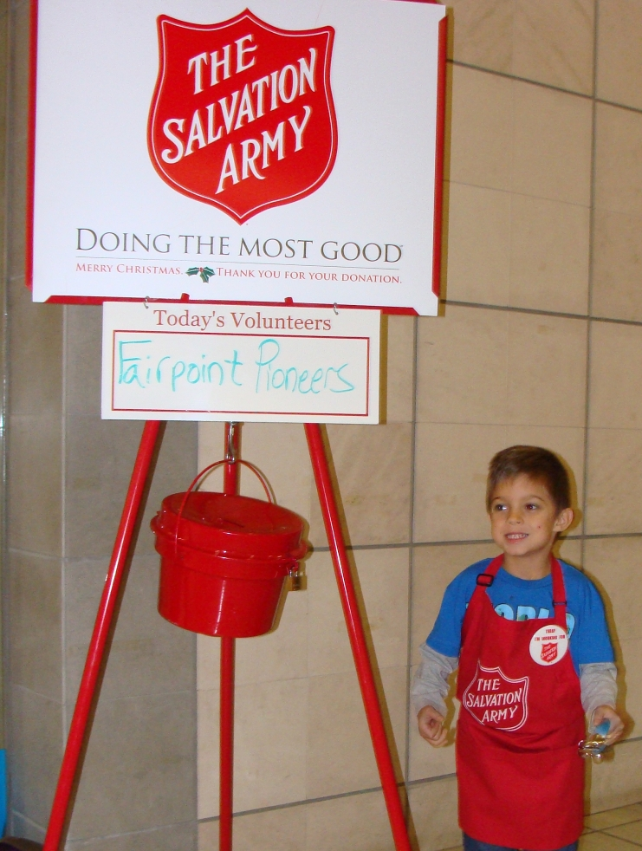
“Sock – it – to me”
A new signature project from the Jasper N Keller Chapter #33



It consists of a pair of socks and a book, together in a zip lock baggie. These will be donated to homeless shelters and other organizations with in the Keller Chapter area. If you know of any agency that would benefit from this project please let the office know. If you would like to donate to this project please send all donations large or small to the Pioneer office 770 Elm St., Manchester, NH 03101.
November Trivia Quiz Answers!
- Topaz
- 1963
- November 19, 1863
- 9th
- Election Day
- Daniel Boone
- 30
- Scorpio and Sagittarius
9. In Latin it means "nine"
10. All Saints Day
11. November 11, 1880

Who was Ned Kelly, you ask.... Ned Kelly: was born in June 1855, in Beveridge, Victoria. died at the gallows in Melbourne Gaol. He was the eldest son of eight children to John 'Red' Kelly and Ellen Quinn. He and his gang killed 3 policemen. His daring and notoriety made him an iconic figure in Australian history, folklore, literature, art and film.

VT LMC - 10 Week Winners

Week 1 | Week 6
Mary-Pierce Minch | Jean Highter
Greg Owens | Barb Simeon
Janet Carty | Jeannette Albanese
Richard Sterling | Philippa Merchand
Sandra Gonyeau | Linda Gibson
Week 2 | Week 7
Diana Prokorimer | Tom Simeon
Betty Millard | Andy Farrington
Gary Morse | Roger Webster
Gerald Nadeau | Patricia Rainville
Lucas Brown | George LaCasse
Week 3 | Week 8
Linda Gibson | Connor Brown
Arden Legge | Janet Wilson
Mary McMaster | Allison Weinhagen
Gary Simpson | Chrystal Fox
Jean Bing | Kitty Burke
Week 4 | Week 9
Stanley Titus
Lorretta Dionne
Michael Marcroft
Patricia Bushway
Audrey Turner
Week 5 | Week 10
Corrine Myers
Robert Ammel
Nancy Young
Tristan Stetson
Kay Critchlow



