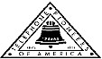 Jasper N. Keller Chapter #33
“Answering the call of those in need”
ISSUE 3, VOL. 10 October 2014

From the President’s desk…
Life is not fair…. I know that everything happens for a reason, if I only knew the reason. Not that it would make the situation any easier, but maybe…I do believe that prayers and positive thinking does help.
Richard and I just returned from our last camping trip of the year! We were in St. Johnsbury, VT. The leaves were beautiful but an insight of things to come. Now to get the camper ready for winter…move all the stuff that little critters can get into, blow out the water lines and put that “pink” stuff in. I don’t know what takes longer getting ready for winter or getting ready for spring….at least, in the spring you have something to look forward to….
I am off to Florida on the 9th of October to a Group Face to Face meeting. It is going to be in Ft Myers….I have never been on the east coast, and my girlfriend lives in Bonita Springs, and I will get to spend a couple of days with her…fun times!
Just finished the Budgets for 2015…looks like another good year coming for the Pioneers….Now to finish up the reports for the year, I know a little early, but need to take them with me to Fl.
Good health and happiness to everyone for the coming holidays!

Jokes So Terrible They’re Actually Funny
Two antennas met on a roof, fell in love and got married. The Ceremony wasn’t much, but the reception was excellent.
A jumper cable walks into a bar. The bartender says, “I’ll serve you, but don’t start anything”.
A woman had twins and gives them up for adoption. One of them goes to a family in Egypt and is named “Ahmal”. The other goes to a family in Spain; they name him “Juan”. Years later, Juan sends a picture of himself to his birth mother. Upon receiving the picture, she tells her husband that she wished she also had a picture of Ahmal. Her husband responds, “They’re twins! If you’ve seen Juan, you’ve seen Ahmal”.
An invisible man marries an invisible woman. The kids were nothing to look at either.

I went to a seafood disco last week … and pulled a mussel.

What do you call a fish with no eyes? A fsh.
Mahatma Gandhi, as you know, walked barefoot most of the time, which produced an impressive set of calluses on his feet. He also ate very little, which made him rather frail and with his odd diet, he suffered from bad breath. This made him. (Oh, man, this is so bad, it’s good…) A super calloused fragile mystic hexed by halitosis.

Monthly Meeting Dates and Times for the Chapter, Council & Life Member Clubs Cont.

Southern NH LMC: Will have the following: Luncheons schedule for 2014: December 11th (turkey dinner). They will be held at the The Yard Restaurant in Manchester, NH. If you are not on the Luncheon list or know someone who should be please contact Bill Macy at 603 890 1572.

Northern NH LMC: Dates for 2014 luncheons will be coming out soon. Please contact Rachel French at rfrench89@gmail.com for more information.

Vermont
Vermont LMC: 10/08/2014 - VT LMC fall luncheon will be at Steak House Restaurant
1239 US Route 302-Berlin Barre, VT 05641. Choice of Chicken Pot Pie or Fresh chopped sirloin & gravy. $14.00 each deadline for reservations is 10/3/2014. Checks should be made out to the VT LM Club and sent to Kay Hopkins. Please contact Kay Hopkins for more information at 802-684-2124 (house), 802-535-4702 (cell).

You can never have too many friends. Please ‘like’ us to keep up with what’s going on in the Jasper N. Keller Chapter #33. Here is the link to use for Facebook

https://www.facebook.com/pages/Pioneers-FairPoint-Jasper-N-Keller-Chapter-33/177159619001637?ref=hl



Monthly Meeting Dates and Times for the Chapter, Council & Life Member Clubs

Maine
Portland Council: Meets the 2nd Tuesday of each month from 9 am to 11 am at 1 Davis Farm Rd., Portland, Me. Contact Christina Shea for more details at: mainepioneers@fairpoint.com.

Bangor Life Member Club:
For more information please contact Cindy Black at eastport4the4th@msn.com.

Kennebec Life Member Club: Meets the last Wednesday of the month at 11:00 am alternately in Waterville or Augusta. Please contact Kathy Camann at 207-872-2355 or dkcamann@myfairpoint.net for locations or more information.
Portland Life Member Club: Meets the 2nd Thursday of each month at 11:30 am at Thatcher’s Restaurant, Foden Rd. S Portland, Me…Any retirees in the Portland area please come and join us.

New Hampshire

New Hampshire Council: Meets the 3rd Thursday of each month from 3 p.m. to 6 p.m. at 875 Holt Ave., Manchester, NH contact Pascale Coates for more details at 603 479 4718

Dover/Portsmouth LMC: Meets the 2nd Tuesday of each month starting at 11:30 am at Rogers Pizza at 869 Central Ave, Dover, NH. Contact Kim Paradis for more details at 603 664 7744

What’s going on in the Council’s?

Maine – Portland Council

New Hampshire – NH Council

October 11, 2014
Northwood Meadows State Park
Northwood, NH
Clean up day – 8 am to Noon
There is something for everyone…Come and join in the fun. 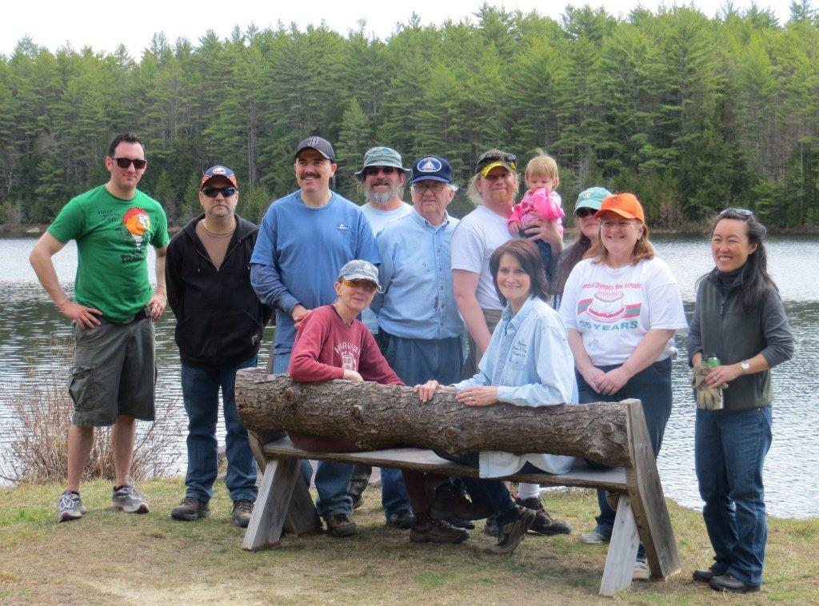
Note your calendar!
November 30th 1 pm
Salem Christmas Parade
December 6th 4 pm
Manchester Christmas Parade
Any one interested in participating please contact Mary Lefebvre at marypl@myfairpoint.net
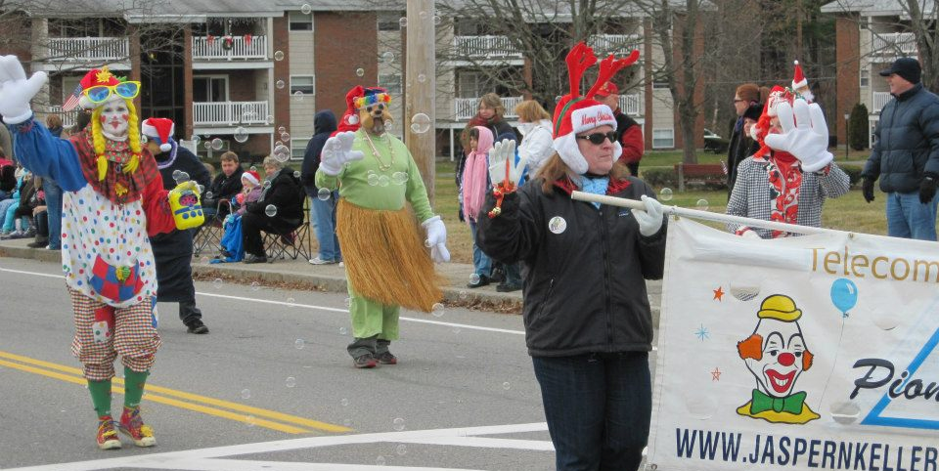

Want to get involved?





250 Brackett St, Portland, Me
Schedule for 2014
Volunteers Welcome!
Please contact Renee Dugas at
207-797-1635
Ronald McDonald Guest Chef
2014 & 2015
- October 13, 2014 – 5 Davis Farm Rd
- November 10, 2014 – 45 Forest Ave
- December 8, 2014 – Life Members
- January 12, 2015 – 5 Davis Farm Rd
- February 9, 2015 – 45 Forest Ave
- March 9, 2015 – Life Members
- April 13, 2015 – 5 Davis Farm Rd
- May 11, 2015 – 45 Forest Ave
- June 8, 2015 – Life Members
- July 13, 2015 – 5 Davis Farm Rd
- August 10, 2015 – 45 Forest Ave
- September 14, 2015 – Life Members
- October 12, 2015 – 5 Davis Farm Rd
- November 9, 2015 – 45 Forest Ave
- December 14, 2015 – Life Members



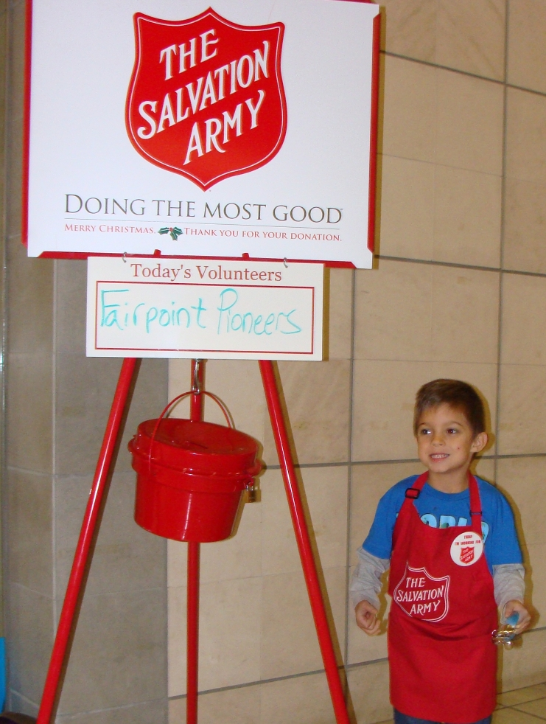
“Sock – it – to me”
A new signature project from the Jasper N Keller Chapter #33



It consists of a pair of socks and a book, together in a zip lock baggie. These will be donated to homeless shelters and other organizations with in the Keller Chapter area. If you know of any agency that would benefit from this project please let the office know. If you would like to donate to this project please send all donations large or small to the Pioneer office 770 Elm St., Manchester, NH 03101.

Remember to turn your clocks back on Sunday October 5th



The Statue of Liberty:
- New York harbor, USA.
- The people of France.
- Crates
- 1886
5. The American Declaration of Independence inscribed in it (July 4, 1776).
6. Chain
7. 305 feet
8. in Paris, 1878.
9. Bledloe's Island.
10. Paris, Las Vegas

VT LMC - 10 Week Winners

Week 1 | Week 6
Mary-Pierce Minch | Jean Highter
Greg Owens | Barb Simeon
Janet Carty | Jeannette Albanese
Richard Sterling | Philippa Merchand
Sandra Gonyeau | Linda Gibson
Week 2 | Week 7
Diana Prokorimer | Tom Simeon
Betty Millard | Andy Farrington
Gary Morse | Roger Webster
Gerald Nadeau | Patricia Rainville
Lucas Brown | George LaCasse
Week 3 | Week 8
Linda Gibson | Connor Brown
Arden Legge | Janet Wilson
Mary McMaster | Allison Weinhagen
Gary Simpson | Chrystal Fox
Jean Bing | Kitty Burke
Week 4 | Week 9
Stanley Titus
Lorretta Dionne
Michael Marcroft
Patricia Bushway
Audrey Turner
Week 5 | Week 10
Corrine Myers
Robert Ammel
Nancy Young
Tristan Stetson
Kay Critchlow



