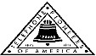 Jasper N. Keller Chapter #33
“Answering the call of those in need”
ISSUE 3, VOL. 9 September 2014

From the President’s desk…
School has started already! I thought it was just Memorial Day last week….Please be careful of the kiddo’s running to get the bus…I did see a really really close call this morning as I was driving to work…luckily the mom was paying attention…because the driver of the car was to busy chatting on the cell phone. Concord, NH did a really interesting thing..they started school on Tuesday and went until Thursday, therefore, they have made up 3 “snow days” before they already happen…Great idea and great planning on the education department’s management. Off for your last camping trip on the season in a couple of weeks…makes me sad…you meet so many interesting people. On our last trip to Maine, I met a retired “Telephone” man from Florida…he had worked in NY at the Twin Towers…many great stories. You just never know who will be parked next to you.
Cathy ann Dow and myself attended the Celebration of Life for Diane Nelson last week..It was very nice…she touched so many lives. She will be sadly missed. My wasp nest is still on the railing on the porch and getting bigger…just wait until the first frost….than they will be out of here. Stay safe and watch out for the School Bus.


Pass the Coffee Trivia
- The average person has more than 150 of these, but only uses 15...?
- When we buy this, on average we will throw 22% of it away?
- During their lifetime, the average person buys 7 of these. What?
- 5 in 6 Americans under the age of 18 have never used one of these. What is it?
- 1 in 4 men say they'd never date a woman who had more than one of these. What?
- One-third of the U.S. population will eat this sometime in the next 2 weeks. What is it?
- American (I think (men)) tosses away 92% of these without using them. What?
- Having this can knock as much as $12,000 off the value of your home if you are trying to sell it. What?
- According to a new study, men get 63% of these. What?
- It's estimated that 32% of parents now send their kids to school with this every day. What is it?
- There are an estimated 480,000 of these in the United States. What?
- Only about 28% of American households still have these. What?

Monthly Meeting Dates and Times for the Chapter, Council & Life Member Clubs Cont.

Southern NH LMC: Will have the following: Luncheons schedule for 2014: Sept. 25th & December 11th (turkey dinner). They will be held at the The Yard Restaurant in Manchester, NH. If you are not on the Luncheon list or know someone who should be please contact Bill Macy at 603 890 1572.

Northern NH LMC: Dates for 2014 luncheons will be coming out soon. Please contact Rachel French at rfrench89@gmail.com for more information.

Vermont
Vermont LMC: 10/08/2014 - VT LMC fall luncheon will be at Steak House Restaurant
1239 US Route 302-Berlin Barre, VT 05641. Choice of Chicken Pot Pie or Fresh chopped sirloin & gravy. $14.00 each deadline for reservations is 10/3/2014. Checks should be made out to the VT LM Club and sent to Kay Hopkins. Please contact Kay Hopkins for more information at 802-684-2124 (house), 802-535-4702 (cell).

You can never have too many friends. Please ‘like’ us to keep up with what’s going on in the Jasper N. Keller Chapter #33. Here is the link to use for Facebook

https://www.facebook.com/pages/Pioneers-FairPoint-Jasper-N-Keller-Chapter-33/177159619001637?ref=hl

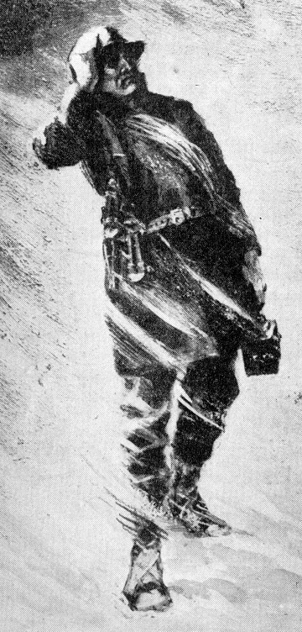

Monthly Meeting Dates and Times for the Chapter, Council & Life Member Clubs

Maine
Portland Council: Meets the 2nd Tuesday of each month from 9 am to 11 am at 1 Davis Farm Rd., Portland, Me. Contact Christina Shea for more details at: mainepioneers@fairpoint.com.

Bangor Life Member Club:
For more information please contact Cindy Black at eastport4the4th@msn.com.

Kennebec Life Member Club: Meets the last Wednesday of the month at 11:00 am alternately in Waterville or Augusta. Please contact Kathy Camann at 207-872-2355 or dkcamann@myfairpoint.net for locations or more information.
Portland Life Member Club: Meets the 2nd Thursday of each month at 11:30 am at Thatcher’s Restaurant, Foden Rd. S Portland, Me…Any retirees in the Portland area please come and join us.

New Hampshire

New Hampshire Council: Meets the 3rd Tuesday of each month from 3 p.m. to 6 p.m. at 875 Holt Ave., Manchester, NH contact Pascale Coates for more details at 603 479 4718

Dover/Portsmouth LMC: Meets the 2nd Tuesday of each month starting at 11:30 am at Rogers Pizza at 869 Central Ave, Dover, NH. Contact Kim Paradis for more details at 603 664 7744

Thank you letter from Grahamtastic’s

To the Portland Council & Jasper N. Keller Chapter:

How kind of you to send information on the Jasper Keller Chapter of the Pioneers, “the largest industry-related volunteer organization”! WOW! The transformative impact your organization has on communities is remarkable. The completely handicapped accessible State Park in Northwood NH and other such projects are commendable efforts.

It was my pleasure to meet all of you last week. FairPoint’s generous gift of laptops, Julie’s personal contribution of another laptop and the Pioneers gift of an Ipad mini, as well as, your group’s enthusiastic and supportive response to Grahamtastic Connection made a lasting impression. I wish Leslie Morissette, our founder and Executive Director, had been able to also be present; perhaps at another time.

Grahamtastic Connection thanks all of you.

Marcel Gagnon
President, BOD

Thank you!
August 21, 2014
Dear Telcom Pioneers,
On behalf of the Allenstown, NH Elementary School community, I want to sincerely thank you for the donations of the school supplies that included: notebooks, paper, binders, pencil boxes, rulers, page dividers, folders, glue sticks, scissors, and erasers. The school supplies go along way to support our staff and students.
Anthony H. Blinn
Principal
Allenstown NH Elementary School

Want to get involved?



Ronald McDonald House
250 Brackett St, Portland, Me
Schedule for 2014
Volunteers Welcome!
Please contact Christina Shea at
603 227 3557

2014 Dates & who’s Responsible
- October 13, 2014 – 5 Davis Farm Rd
- November 10, 2014 – 45 Forest Ave
- December 8, 2014 – Life Members

What’s going on in the Council’s?

Maine – Portland Council

New Hampshire – NH Council
VT LMC - 10 Week Winners
Week 1
Mary-Pierce Minch
Greg Owens
Janet Carty
Richard Sterling
Sandra Gonyeau
Week 2
Diana Prokorimer
Betty Millard
Gary Morse
Gerald Nadeau
Lucas Brown
Week 3
Linda Gibson
Arden Legge
Mary McMaster
Gary Simpson
Jean Bing


“Sock – it – to me”
A new signature project from the Jasper N Keller Chapter #33



It consists of a pair of socks and a book, together in a zip lock baggie. These will be donated to homeless shelters and other organizations with in the Keller Chapter area. If you know of any agency that would benefit from this project please let the office know. If you would like to donate to this project please send all donations large or small to the Pioneer office 770 Elm St., Manchester, NH 03101.
Pass the Coffee Trivia
- TV Channels
- Toothpaste
- Washing machines
- Postage stamp
- Cats
- Macaroni & Cheese
- Instructions
- A child's messy bedroom
- Speeding tickets
- Hand sanitizer
- School Buses
- Ice cube trays

The Statue of Liberty:
- New York harbor, USA.
- The people of France.
- Crates
- 1886
5. The American Declaration of Independence inscribed in it (July 4, 1776).
6. Chain
7. 305 feet
8. in Paris, 1878.
9. Bledloe's Island.
10. Paris, Las Vegas


NH Clown Troup
Newly retired Mozo the clown at the Londonderry Old Home Days Parade…The weather couldn’t have been and better and the spectators were great…Thanks again to everyone who participated.


